Product Upgrade Guide v4.0.5.2

Contents
1 Document Control 5
1.1 Author 5
1.2 Document Summary 5
1.3 Document History 5
1.4 Reference documents 5
1.5 Distribution 6
1.6 Quality Assurance 6
2 Introduction 7
2.1 Purpose 7
2.2 Products Covered by this Guide 8
2.3 Order in which to Upgrade/(Install) Products 9
2.4 Pre-Requisites to Upgrade 10
3 Network Manager 13
3.1 Installation of the Network Manager Software files 13
3.2 Network Manager Server Upgrade 14
3.2.1 Before you Start 14
3.2.2 Typical problems that you may encounter 14
3.2.3 Upgrade of Network Manager 14
3.2.4 Mandatory Configuration 15
3.2.5 Additional Configuration 16
3.2.6 Spatial Configuration 16
4 Street Gazetteer Manager 17
4.1 Implementation of the Street Gazetteer Manager Software files 17
4.2 Street Gazetteer Manager Server Upgrade 18
4.2.1 Before you Start 18
4.2.2 Typical problems that you may encounter 18
4.2.3 Upgrade of Street Gazetteer Manager 18
4.2.4 Mandatory Configuration 19
5 TMA Manager 20
5.1 Implementation of the TMA Manager Software files 20
5.2 TMA Manager Server Upgrade 21
5.2.1 Before you Start 21
5.2.2 Typical problems that you may encounter 21
5.2.3 Upgrade of TMA Manager 22
5.2.4 Mandatory Configuration 23
6 TMA API 29
6.1 Implementation of the TMA API Software files 29
6.2 TMA API Server Upgrade 30
6.2.1 Before you Start 30
6.2.2 Typical problems that you may encounter 30
6.3 TMA External Notice API Implementation 31
6.3.1 Deployment of API Software Files 31
6.3.2 API Server Component Install 31
7 Streetworks Manager 33
7.1 Implementation of the Streetworks Manager Software files 33
7.2 Streetworks Manager Server Upgrade 34
7.2.1 Before you Start 34
7.2.2 Typical problems that you may encounter 34
7.2.3 Upgrade of Streetworks Manager 34
7.2.4 Mandatory Configuration 35
7.2.5 Additional Configuration 36
7.2.6 Spatial Configuration 36
8 Maintenance Manager 37
8.1 Implementation of the Maintenance Manager Software files 37
8.2 Maintenance Manager Server Upgrade 38
8.2.1 Before you Start 38
8.2.2 Typical problems that you may encounter 38
8.2.3 Upgrade of Maintenance Manager 38
8.2.4 Mandatory Configuration 39
8.2.5 Additional Configuration 40
8.2.6 Spatial Configuration 40
9 Public Enquiry Manager 41
9.1 Implementation of the Public Enquiry Manager Software files 41
9.2 Public Enquiry Manager Server Upgrade 42
9.2.1 Before you Start 42
9.2.2 Typical problems that you may encounter 42
9.2.3 Upgrade of Public Enquiry Manager 42
9.2.4 Mandatory Configuration 43
9.2.5 Additional Configuration 44
9.2.6 Spatial Configuration 44
10 Asset Valuation Manager 45
10.1 Implementation of the Asset Valuation Manager Software files 45
10.2 Asset Valuation Manager Server Upgrade 46
10.2.1 Before you Start 46
10.2.2 Typical problems that you may encounter 46
10.2.3 Upgrade of Asset Valuation Manager 46
10.2.4 Mandatory Configuration 47
10.2.5 Additional Configuration 48
11 Accidents Manager 49
11.1 Implementation of the Accidents Manager Software files 49
11.2 Accidents Manager Server Upgrade 50
11.2.1 Before you Start 50
11.2.2 Typical problems that you may encounter 50
11.2.3 Upgrade of Accidents Manager 50
11.2.4 Mandatory Configuration 51
11.2.5 Additional Configuration 52
12 Public Rights Of Way Manager 53
12.1 Implementation of the Public Rights Of Way Manager Software files 53
12.2 Public Rights Of Way Manager Server Upgrade 54
12.2.1 Before you Start 54
12.2.2 Typical problems that you may encounter 54
12.2.3 Upgrade of Public Rights Of Way Manager 54
12.2.4 Mandatory Configuration 55
12.2.5 Additional Configuration 56
13 Street Lighting Manager 57
13.1 Implementation of the Street Lighting Manager Software files 57
13.2 Street Lighting Manager Server Upgrade 58
13.2.1 Before you Start 58
13.2.2 Typical problems that you may encounter 58
13.2.3 Upgrade of Street Lighting Manager 58
13.2.4 Mandatory Configuration 59
13.2.5 Additional Configuration 60
14 Schemes Manager 61
14.1 Implementation of the Schemes Manager Software files 61
14.2 Schemes Manager Server Upgrade 62
14.2.1 Before you Start 62
14.2.2 Typical problems that you may encounter 62
14.2.3 Upgrade of Schemes Manager 62
14.2.4 Mandatory Configuration 63
14.2.5 Additional Configuration 64
15 Structures Manager 65
15.1 Implementation of the Structures Manager Software files 65
15.2 Structures Manager Server Upgrade 66
15.2.1 Before you Start 66
15.2.2 Typical problems that you may encounter 66
15.2.3 Upgrade of Structures Manager 66
15.2.4 Mandatory Configuration 67
15.2.5 Additional Configuration 68
16 Traffic Interface Manager 69
16.1 Implementation of the Traffic Interface Manager Software files 69
16.2 Traffic Interface Manager Server Upgrade 70
16.2.1 Before you Start 70
16.2.2 Typical problems that you may encounter 70
16.2.3 Upgrade of Traffic Interface Manager 70
16.2.4 Mandatory Configuration 71
16.2.5 Additional Configuration 72
17 UKPMS 73
17.1 Implementation of the UKPMS Software files 73
17.2 UKPMS Server Upgrade 74
17.2.1 Before you Start 74
17.2.2 Typical problems that you may encounter 74
17.2.3 Upgrade of UKPMS 74
17.2.4 Mandatory Configuration 75
17.2.5 Additional Configuration 76
18 Main Roads Western Australia 77
18.1 Implementation of the Main Roads Western Australia Software files 77
18.2 Main Roads Western Australia Server Upgrade 78
18.2.1 Before you Start 78
18.2.2 Typical problems that you may encounter 78
18.2.3 Upgrade of Main Roads Western Australia 78
18.2.4 Mandatory Configuration 79
18.2.5 Additional Configuration 80
19 Highways Agency Interface 81
19.1 Implementation of the Highways Agency Interface Software files 81
19.2 Highways Agency Interface Server Install 82
19.2.1 Before you Start 82
19.2.2 Typical problems that you may encounter 82
19.2.3 Install of Highways Agency Interface 82
19.2.4 Mandatory Configuration 83
19.2.5 Additional Configuration 83
20 Mapserver 84
20.1 Implementation of the Mapserver Software files 84
20.2 Mapserver Implementation 85
20.2.1 Deployment of Mapserver Software Files 85
20.2.2 Mapserver Component Install 85

- Document Control
  - Author
Exor Development

  - Document Summary
This document covers steps involved in upgrading the components for:
- Network Manager
- Street Gazetteer Manager
- TMA Manager
- TMA API
- Maintenance Manager
- Public Enquiry Manager
- Streetworks Manager
- Accident Manager
- Asset Valuation Manager
- Traffic Interface Manager
- Public Rights Of Way Manager
- Street Lighting Manager
- Structures Manager
- Schemes Manager
- UKPMS
- Main Roads Western Australia
It also includes the steps involved in installing the components for:
- Highways Agency Interface

  - Document History

Document History
Revision | Date | By | Description
1.0 | 09-Feb-2009 | Exor Development | First Edition

  - Reference documents
None

  - Distribution
Exor Customers, Partners and Staff

  - Quality Assurance
Document Details
File | Prepared By
0000.doc | Exor Development
Document Name | Reviewed By
Product Upgrade Guide v4.0.5.02 | Colin Stewart
Version | Approved for issue by
1.0 | Colin Stewart
Date of Issue | Support Manager
28-Feb-2009 | Graham Anns

- Introduction
  - Purpose
This guide covers steps involved in upgrading the components for:
- Network Manager
- Street Gazetteer Manager
- TMA Manager
- TMA API
- Maintenance Manager
- Public Enquiry Manager
- Streetworks Manager
- Accident Manager
- Asset Valuation Manager
- Traffic Interface Manager
- Public Rights Of Way Manager
- Street Lighting Manager
- Structures Manager
- Schemes Manager
- UKPMS
- Main Roads Western Australia
It also includes the steps involved in installing the components for:
- Highways Agency Interface

Each product upgrade is split into two distinct stages,

- Stage 1 – Implementation of the Software files
- Stage 2 – Upgrade of the Server

  - Products Covered by this Guide
Table 1 lists the relevant products that are covered by this guide.

Product | Install | Upgrade From 4.0.5.1 | Upgrade From 4.0.5.0 | Upgrade From 4.0.4.0
Network Manager | ✗ |  | ✗ | ✗
Street Gazetteer Manager | ✗ |  | ✗ | ✗
TMA Manager | ✗ |  | ✗ | ✗
TMA API | ✗ |  | ✗ | ✗
Street Works Manager | ✗ | ✗ |  | ✗
Maintenance Manager | ✗ | ✗ |  | ✗
Public Enquiry Manager | ✗ | ✗ |  | ✗
Asset Valuation Manager | ✗ | ✗ |  | ✗
Accidents Manager | ✗ | ✗ |  | ✗
Public Right Of Way Manager | ✗ | ✗ |  | ✗
Street Lighting Manager | ✗ | ✗ |  | ✗
Schemes Manager | ✗ | ✗ |  | ✗
Structures Manager | ✗ | ✗ |  | ✗
Traffic Interface Manager | ✗ | ✗ |  | ✗
UKPMS | ✗ | ✗ |  | ✗
Main Roads Western Australia | ✗ | ✗ | ✗ | 
Highways Agency Interface |  | n/a | n/a | n/a
Table 1: List of products covered by this guide

  - Order in which to Upgrade/(Install) Products
Table 2 lists the order in which to upgrade/(Install) the products in this release.

Product to Upgrade/(Install) | Order to Upgrade/(Install)
Network Manager | 1
Street Gazetteer Manager | 2
TMA Manager | 3
TMA API | 4
Street Works Manager | 5
Maintenance Manager | 6
Public Enquiry Manager | 7
Asset Valuation Manager | 8
Accidents Manager | 9
Public Right Of Way Manager | 10
Street Lighting Manager | 11
Schemes Manager | 12
Structures Manager | 13
Traffic Interface Manager | 14
Main Roads Western Australia | 15
UKPMS | 16
Highways Agency Interface | 17
Table 2: Order in which to upgrade products

  - Pre-Requisites to Upgrade
It is assumed that the audience of this document understand the configuration of the servers being upgraded and are sufficiently proficient with SQL*Plus. It is also assumed that the terminology used in this document is understood by the reader.

NB. The instructions for installation of the software describes the installation of all the software into a single area (usually referred to as the ‘Client’). The instructions for upgrading the Server (your Highways schema) assume you have access to the database from the ‘Client’.

Your configuration and server access may differ from this; the InstallShield can still be used for installation. For example, you may have to install the Client software on the Application Server and the Server software on the Database Server for reasons of database access availablilty from the Application Server.

If in any doubt please contact support@exorcorp.com.

Before attempting to upgrade, you should ensure that;

- the appropriate software components are installed and are compatible with the exor certification matrix. The certification matrix can be downloaded from the Client area of the exor website.

- all users are disconnected from the system

- the highways listener processes are not running

- a database export of the owner of Highways owner has been taken.

- You MUST copy the current <exor_base> directory and sub-directory structure and contents to a new area (e.g. <exor_base4050>). This ensures that a copy is available for backup or reference purposes should any issues arise during the installation.
The installation can then continue into a new area (e.g. <exor_install4051>) which should then be copied onto the <exor_base>.

For Example:
….copy the current <exor_base> directory and sub-directory structure and contents to a new area (e.g. <exor_base4050>)

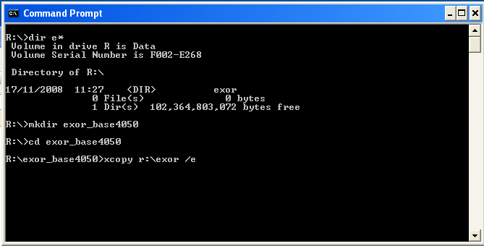

… The installation can then continue into a new area (e.g. <exor_install4051>)

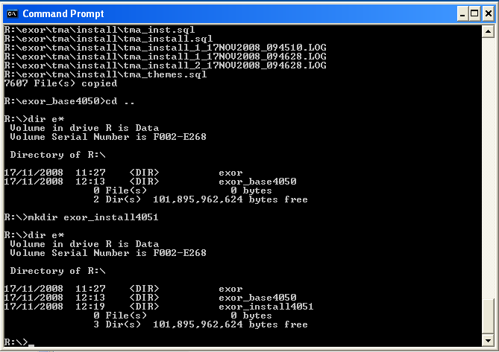

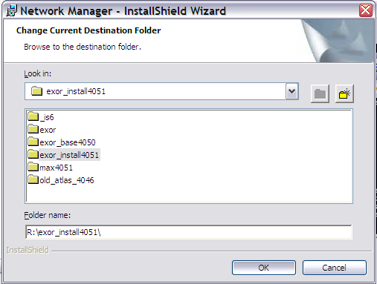

… which should then be copied onto the <exor_base>

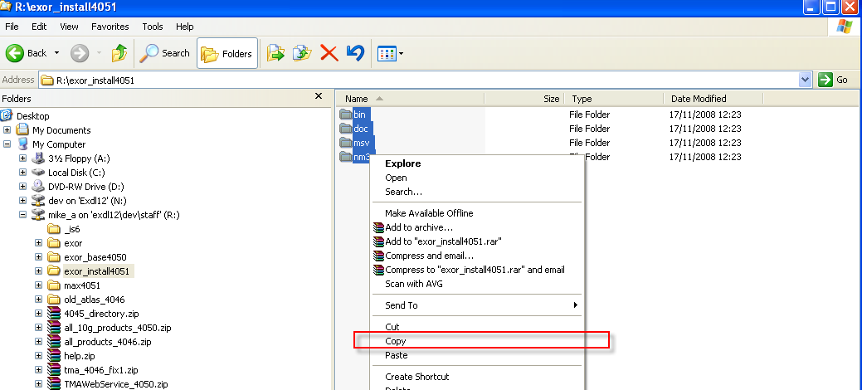

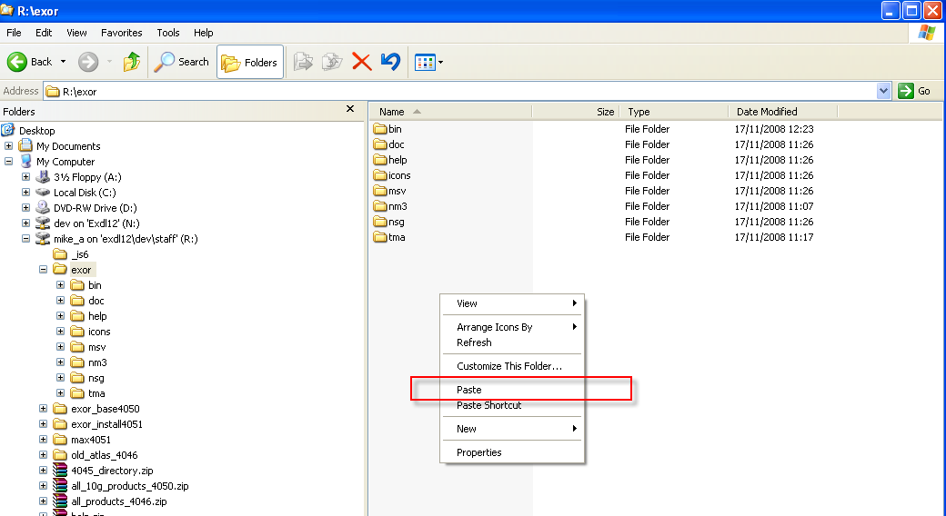

If you are upgrading the TMA Web Server also refer to page 20.

- Network Manager
  - Installation of the Network Manager Software files
To install the software components for Network Manager execute the setup_network_manager_4052.exe and follow the on-screen prompts.

Extremely Important (For TMA users):

This is a patch release to be installed on top of release 4.0.5.1

It is crucial that when selecting the ‘Destination Folder’, you select that directory under which the existing 4.0.5.1 software resides.

When the wizard completes, the necessary client and server software files will have been installed.

Notes:
A password is required to be entered during this process. If you are not sure of the password contact support@exorcorp.com.

  - Network Manager Server Upgrade
This chapter provides details of steps involved in upgrading the server components for Network Manager.

Important:
This product will require upgrading before TMA Manager and Street Gazetteer Manager.

    - Before you Start

Before proceeding please ensure that the pre-requisites mentioned in Section 2.3 of this document are met.

Also, please be aware of the following;

Where instructed to change to a directory before running a script, it is assumed that you are running SQL*PLUS from a DOS Command prompt.

If you are running SQL*PLUS in windows you should set the 'start in' directory of the SQL*PLUS shortcut to simulate the change of directory.

If you do not run SQL*PLUS from the directory stated in each step of the guide, the installation will fail.

Also, whilst following the instructions in this section you will be required to know the location of <exor_base>. You may recall that whilst undertaking the tasks in Section 3.1 you will have implemented software into the location referred to as <exor_base>, for example, C:\EXOR.

    - Typical problems that you may encounter

It is possible that, when you are running some of the upgrade scripts, errors may be reported saying that objects already exist in the database or that columns already exist on tables. These errors can generally be ignored. If you are in any doubt, please contact the Exor support desk for guidance.

The upgrade procedures will also attempt to install database roles in the highways owner account that are necessary for the system to operate correctly. You may find that errors are produced when running the upgrade scripts to the effect that the role names being created are already used by existing roles or users. These errors can be ignored as they simply mean that the roles being created already exist.

Also during upgrade Warning messages may appear saying that compilation errors have occurred. These warnings can be ignored, since invalid objects will be recompiled prompt later on in the upgrade. However it will be of concern if compilation errors still occur following the re-compilation.

    - Upgrade of Network Manager

This section describes the steps necessary to upgrade Network Manager to 4.0.5.2

Important
The server upgrade relies on invoking scripts shipped with the previous release. Therefore it is essential that the software was installed into the correct destination folder, as instructed in the previous chapter.

To upgrade the base data and objects for the Network Manager modules;

- Change directory to <exor_base>\nm3\install

- Login to SQL*PLUS as the highways owner on the client PC

- Run the following command
start nm4051_nm4052.sql

- You will be prompted to enter the path of the location of your highways software. This should be name of the directory, including disk identifier and a trailing slash character, referred to as <exor_base>.

For example, if you installed your highways software in a directory called EXOR on your C drive, you would enter the following when prompted.

C:\EXOR\

- When you have supplied this value, you will be prompted to confirm that it is correct and asked whether you wish to continue.

- If the value specified is not correct or does not end with a slash character, you will be given an error message and the installation script will abort. You will then need to login to SQL*PLUS again and rerun the script.

- When the script has completed, all the Network Manager objects and data will have been upgraded.

Checking Log File(s)

The following log files are produced in the working directory. At the end of the upgrade, they can be viewed to check for any errors that could have occurred during the upgrade process.

nm4051_nm4052_1_<date&time>.LOG
nm4051_nm4052_2_<date&time>.LOG

Log files should be emailed to support@exorcorp.com to allow exor support staff to verify the upgrade has been successful.

Due to interdependencies between some Exor products, please ignore all compilation errors until all of your products have been upgraded.

    - Mandatory Configuration

exor_version.txt

Before accessing Network Manager you must check the file exor_version.txt.

This file is referenced in Windows Registry setting ‘EXOR_VERSION’ and by default can be located in the <exor_base>\bin directory.

Ensure that the entry for Network Manager is set accordingly;

NET=4.0.5.2
HIG=4.0.5.2
AST=4.0.5.2
DOC=4.0.5.2
WMP=4.0.5.2

    - Additional Configuration

Consult the documentation that accompanies this release for details of any additional configuration that may be required following an upgrade.

For example, to obtain details of product options, and for details of new product features/amendments.

Important:
It is highly recommended that you do this before attempting to use the application.

    - Spatial Configuration

Specific information regarding the registration of spatial layers can be found in the “Locator and Web Mapping” document.

- Street Gazetteer Manager
  - Implementation of the Street Gazetteer Manager Software files
To install the software components for Street Gazetteer Manager execute the setup_street_gazetteer_manager_4052.exe and follow the on-screen prompts.

Extremely Important:

This is a patch release to be installed on top of release 4.0.5.1

It is crucial that when selecting the ‘Destination Folder’, you select that directory under which the existing 4.0.5.1 software resides.

When the wizard completes, the necessary client and server software files will have been installed.

Notes:
A password is required to be entered during this process. If you are not sure of the password contact support@exorcorp.com.

  - Street Gazetteer Manager Server Upgrade
This chapter provides details of steps involved in upgrading the server components for Street Gazetteer Manager.

Important:
This product will require upgrading after Network Manager and before TMA Manager.

    - Before you Start

Before proceeding please ensure that the pre-requisites mentioned in Section 2.3 of this document are met.

Also, please be aware of the following;

Where instructed to change to a directory before running a script, it is assumed that you are running SQL*PLUS from a DOS Command prompt.

If you are running SQL*PLUS in windows you should set the 'start in' directory of the SQL*PLUS shortcut to simulate the change of directory.

If you do not run SQL*PLUS from the directory stated in each step of the guide, the installation will fail.

Also, whilst following the instructions in this section you will be required to know the location of <exor_base>. You may recall that whilst undertaking the tasks in Section 4.1 you will have implemented software into the location referred to as <exor_base>, for example, C:\EXOR.

    - Typical problems that you may encounter

It is possible that, when you are running some of the upgrade scripts, errors may be reported saying that objects already exist in the database or that columns already exist on tables. These errors can generally be ignored. If you are in any doubt, please contact the Exor support desk for guidance.

The upgrade procedures will also attempt to install database roles in the highways owner account that are necessary for the system to operate correctly. You may find that errors are produced when running the upgrade scripts to the effect that the role names being created are already used by existing roles or users. These errors can be ignored as they simply mean that the roles being created already exist.

Also during upgrade Warning messages may appear saying that compilation errors have occurred. These warnings can be ignored, since invalid objects will be recompiled prompt later on in the upgrade. However it will be of concern if compilation errors still occur following the re-compilation.

    - Upgrade of Street Gazetteer Manager

This section describes the steps necessary to upgrade Street Gazetteer Manager to 4.0.5.2

Important
The server upgrade relies on invoking scripts shipped with the previous release. Therefore it is essential that the software was installed into the correct destination folder, as instructed in the previous chapter.

To upgrade the base data and objects for the Street Gazetteer Manager modules;

- Change directory to <exor_base>\nsg\install

- Login to SQL*PLUS as the highways owner on the client PC

- The same script is used to upgrade from the previous version shown in Section 2.2.
Run the following command

start nsg4051_nsg4052.sql

- You will be prompted to enter the path of the location of your highways software. This should be name of the directory, including disk identifier and a trailing slash character, referred to as <exor_base>.

For example, if you installed your highways software in a directory called EXOR on your C drive, you would enter the following when prompted.

C:\EXOR\

- When you have supplied this value, you will be prompted to confirm that it is correct and asked whether you wish to continue.

- If the value specified is not correct or does not end with a slash character, you will be given an error message and the installation script will abort. You will then need to login to SQL*PLUS again and rerun the script.

- When the script has completed, all the Street Gazetteer Manager objects and data will have been upgraded.

Checking Log File(s)

The following log files are produced in the working directory. At the end of the upgrade, they can be viewed to check for any errors that could have occurred during the upgrade process.

nsg4051_nsg4052_1_<date&time>.LOG
nsg4051_nsg4052_2_<date&time>.LOG

Log files should be emailed to support@exorcorp.com to allow exor support staff to verify the upgrade has been successful.

Due to interdependencies between some Exor products, please ignore all compilation errors until all of your products have been upgraded.

    - Mandatory Configuration

exor_version.txt

Before accessing Street Gazetteer Manager you must check the file exor_version.txt.

This file is referenced in Windows Registry setting ‘EXOR_VERSION’ and by default can be located in the <exor_base>\bin directory.

Ensure that the entry for Street Gazetteer Manager is set accordingly;

NSG=4.0.5.2

- TMA Manager
  - Implementation of the TMA Manager Software files

To install the software components for TMA Manager execute the setup_tma_manager_4052.exe and follow the on-screen prompts.

Extremely Important:

This is a patch release to be installed on top of release 4.0.5.1

It is crucial that when selecting the ‘Destination Folder’, you select that directory under which the existing 4.0.5.1 software resides.

When the wizard completes, the necessary client and server software files will have been installed.

Notes:
A password is required to be entered during this process. If you are not sure of the password contact support@exorcorp.com.

  - TMA Manager Server Upgrade
This chapter provides details of steps involved in upgrading the server components for TMA Manager.

Important:
This product will require upgrading after Network Manager and Street Gazetteer Manager.

    - Before you Start

Before proceeding please ensure that the pre-requisites mentioned in Section 2.3 of this document are met.

Also, please be aware of the following;

Extremely Important:

The TMA Web Server should be upgraded to 4.0.5.1 before upgrading TMA Manager.

Before upgrading TMA Manager shutdown the TMA Web Server And Restart it after successfully upgrading TMA Manager.

Where instructed to change to a directory before running a script, it is assumed that you are running SQL*PLUS from a DOS Command prompt.

If you are running SQL*PLUS in windows you should set the 'start in' directory of the SQL*PLUS shortcut to simulate the change of directory.

If you do not run SQL*PLUS from the directory stated in each step of the guide, the installation will fail.

Also, whilst following the instructions in this section you will be required to know the location of <exor_base>. You may recall that whilst undertaking the tasks in Section 5.1 you will have implemented software into the location referred to as <exor_base>, for example, C:\EXOR.

    - Typical problems that you may encounter

It is possible that, when you are running some of the upgrade scripts, errors may be reported saying that objects already exist in the database or that columns already exist on tables. These errors can generally be ignored. If you are in any doubt, please contact the Exor support desk for guidance.

The upgrade procedures will also attempt to install database roles in the highways owner account that are necessary for the system to operate correctly. You may find that errors are produced when running the upgrade scripts to the effect that the role names being created are already used by existing roles or users. These errors can be ignored as they simply mean that the roles being created already exist.

Also during upgrade Warning messages may appear saying that compilation errors have occurred. These warnings can be ignored, since invalid objects will be recompiled prompt later on in the upgrade. However it will be of concern if compilation errors still occur following the re-compilation.

    - Upgrade of TMA Manager

This section describes the steps necessary to upgrade TMA Manager to 4.0.5.2

Important
The server upgrade relies on invoking scripts shipped with the previous release. Therefore it is essential that the software was installed into the correct destination folder, as instructed in the previous chapter.

To upgrade the base data and objects for the TMA Manager modules;

- Change directory to <exor_base>\tma\install

- Login to SQL*PLUS as the highways owner on the client PC

- The same script is used to upgrade from the previous version shown in Section 2.2.
Run the following command

start tma4051_tma4052.sql

- You will be prompted to enter the path of the location of your highways software. This should be name of the directory, including disk identifier and a trailing slash character, referred to as <exor_base>.

For example, if you installed your highways software in a directory called EXOR on your C drive, you would enter the following when prompted.

C:\EXOR\

- When you have supplied this value, you will be prompted to confirm that it is correct and asked whether you wish to continue.

- If the value specified is not correct or does not end with a slash character, you will be given an error message and the installation script will abort. You will then need to login to SQL*PLUS again and rerun the script.

- When the script has completed, all the TMA Manager objects and data will have been upgraded.

Checking Log File(s)

The following log files are produced in the working directory. At the end of the upgrade, they can be viewed to check for any errors that could have occurred during the upgrade process.

tma4051_tma4052_1_<date&time>.LOG
tma4051_tma4052_2_<date&time>.LOG

Log files should be emailed to support@exorcorp.com to allow exor support staff to verify the upgrade has been successful.

Due to interdependencies between some Exor products, please ignore all compilation errors until all of your products have been upgraded.

    - Mandatory Configuration

exor_version.txt

Before accessing TMA Manager you must check the file exor_version.txt.

This file is referenced in Windows Registry setting ‘EXOR_VERSION’ and by default can be located in the <exor_base>\bin directory.

Ensure that the entry for TMA Manager is set accordingly;

TMA=4.0.5.2

ApEx

Log onto the ApEx application.

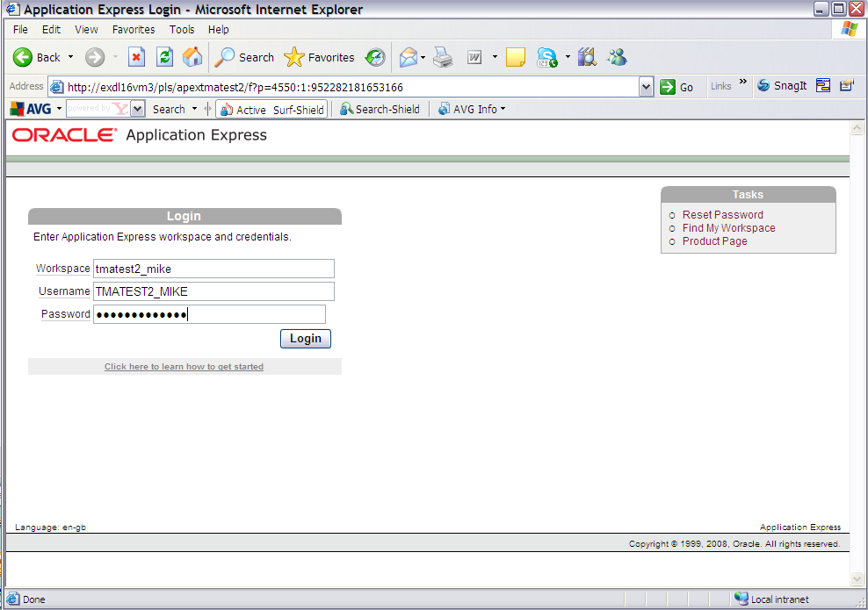

Select the 'Application Builder' option and import

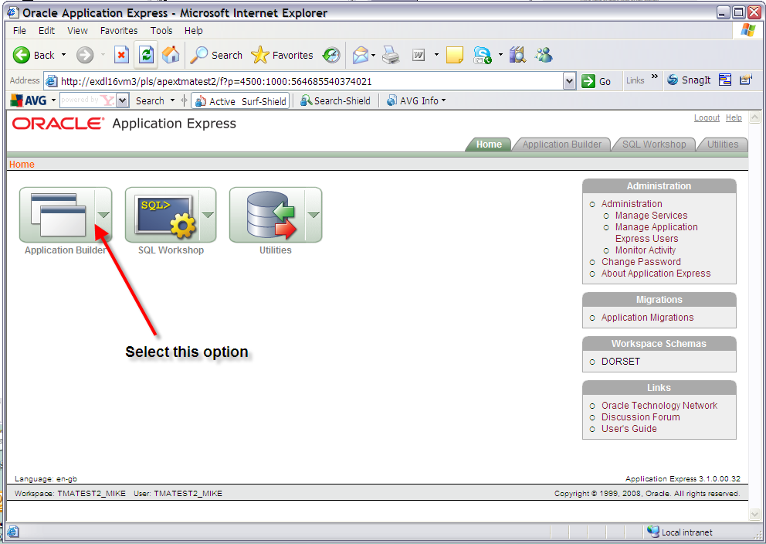

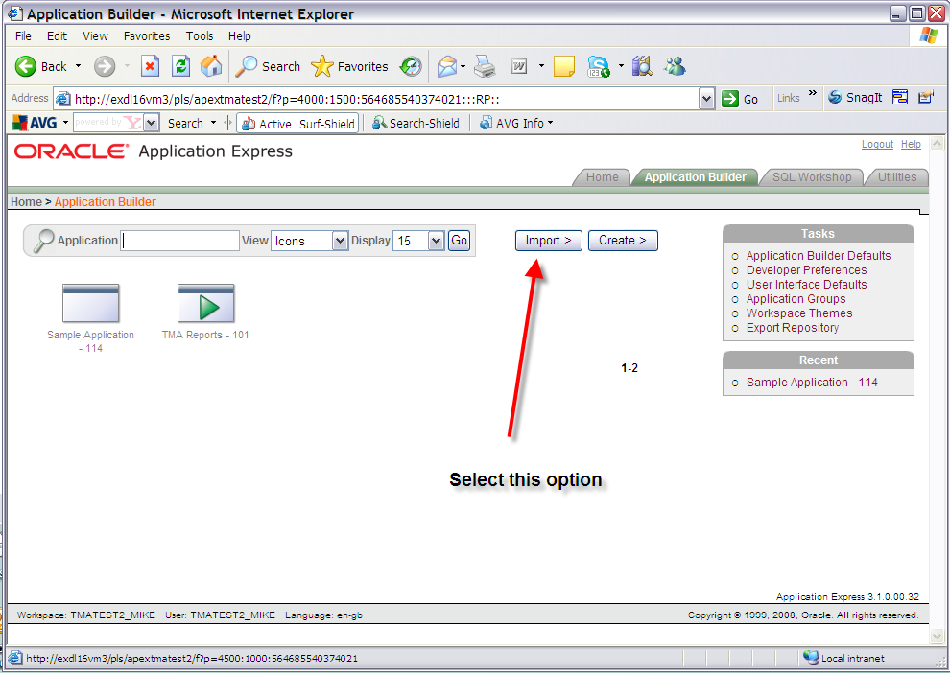

Import the ApEx Reports file under the directory <exor_base>\tma\admin\sql\tma_apex_rpts.sql

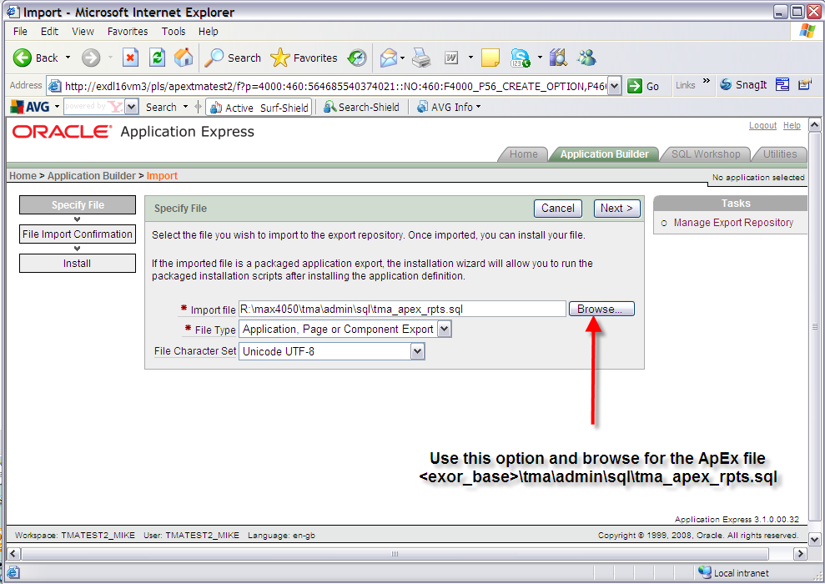

Once the file has been imported you will be met with this screen. Click the next button to proceed.

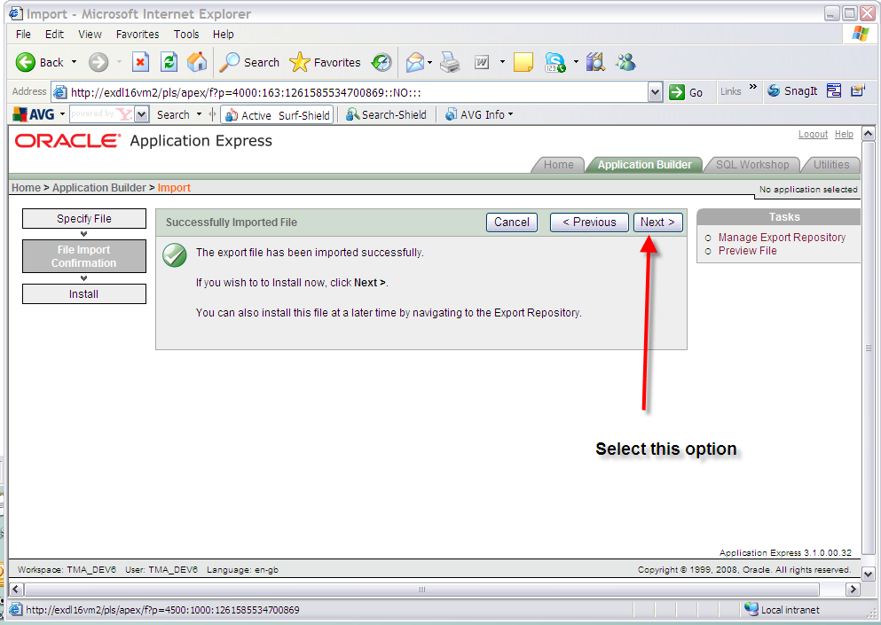

On the install application screen, which should be the screen presented, in the 'Install As Application' option select the 'Reuse Application ID 101 From Export' option and click the Install button. Parsing schema and build status should default values. Ensure that the Parsing Schema is the correct schema and the build status is ‘Run Application Only’.

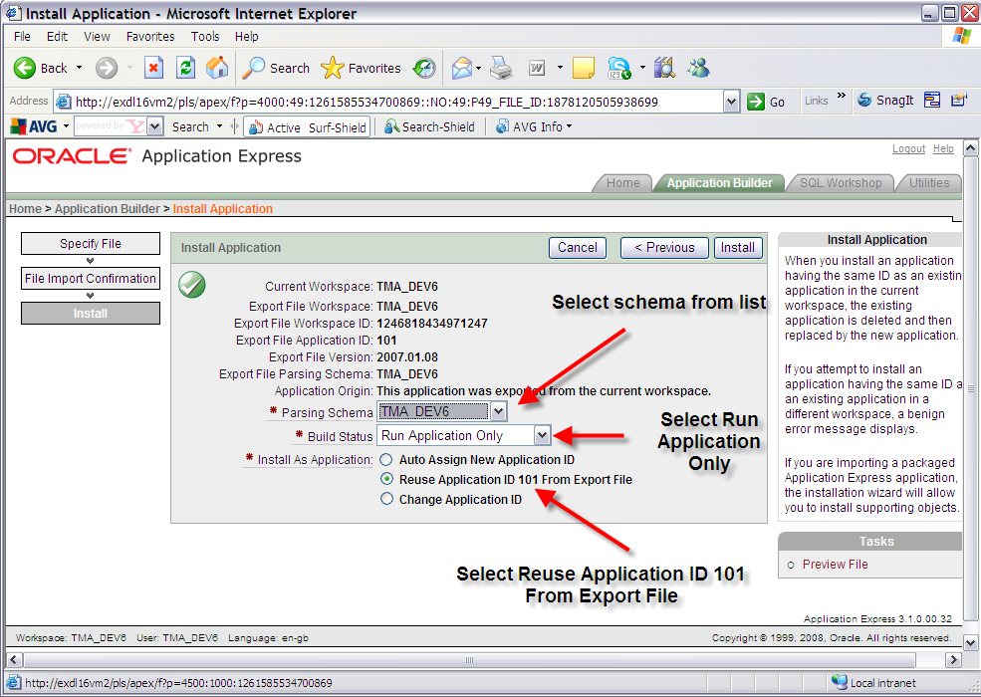

Click the Install button:

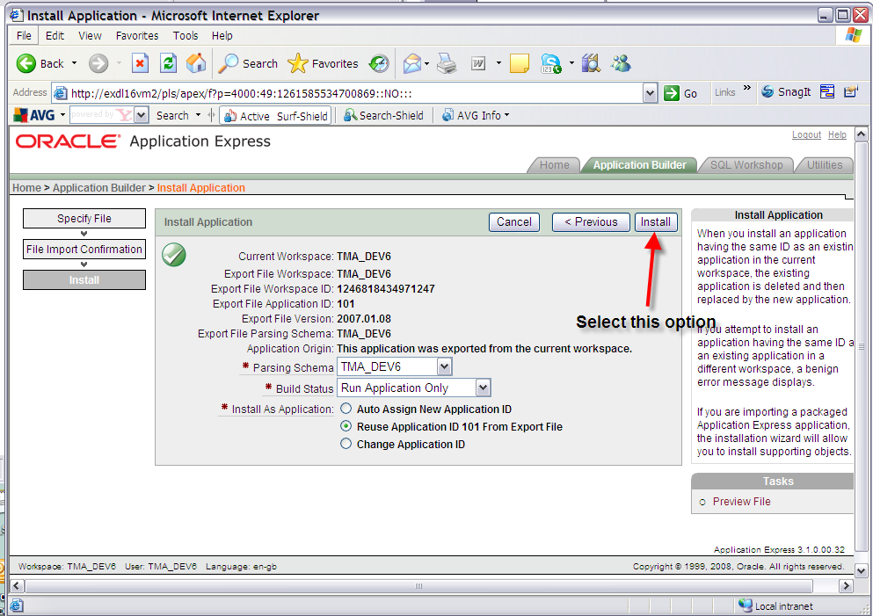

You should be presented with a 'Confirm Replace Application' screen. Click the 'Replace Existing Application' button.

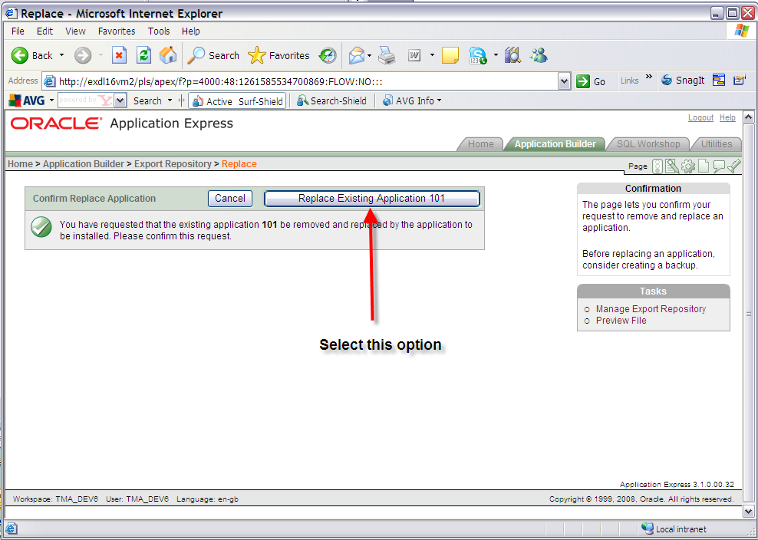

Exit the window which should read 'Application not available for edit'.

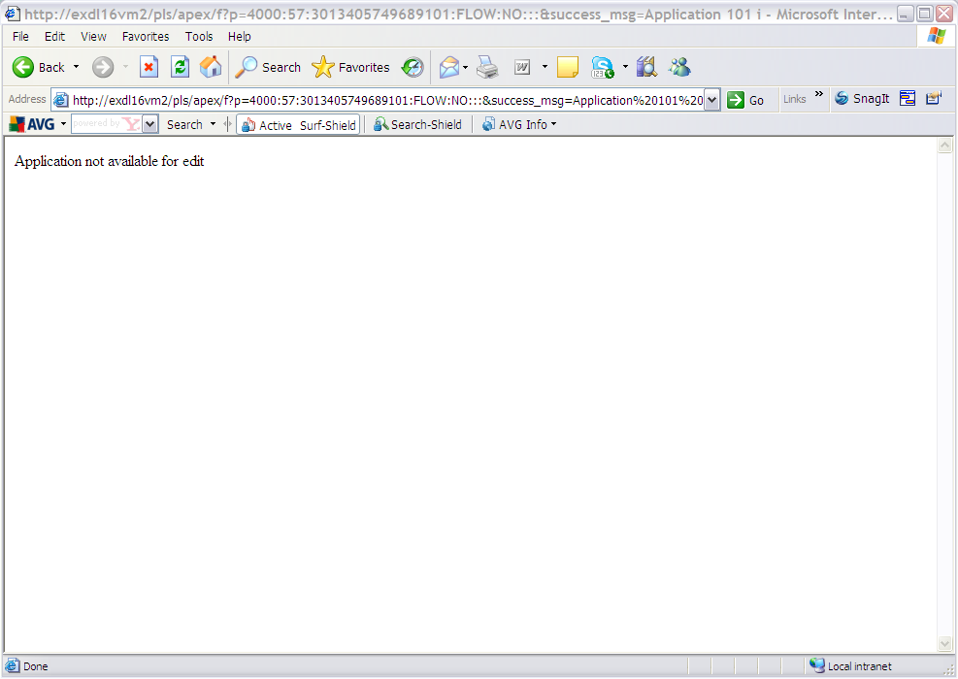

Test the reports from the TMA application.

- TMA API
  - Implementation of the TMA API Software files

To install the software components for TMA Manager execute the setup_tma_api_4052.exe and follow the on-screen prompts.

Extremely Important:

This is a patch release to be installed on top of release 4.0.5.1

It is crucial that when selecting the ‘Destination Folder’, you select that directory under which the existing 4.0.5.1 software resides.

When the wizard completes, the necessary client and server software files will have been installed.

Notes:
A password is required to be entered during this process. If you are not sure of the password contact support@exorcorp.com.

  - TMA API Server Upgrade
This chapter provides details of steps involved in upgrading the server components for TMA Manager.

Important:
This product will require upgrading after Network Manager, Street Gazetteer Manager and TMA Manager.

    - Before you Start

Before proceeding please ensure that the pre-requisites mentioned in Section 2.3 of this document are met.

Also, please be aware of the following;

Where instructed to change to a directory before running a script, it is assumed that you are running SQL*PLUS from a DOS Command prompt.

If you are running SQL*PLUS in windows you should set the 'start in' directory of the SQL*PLUS shortcut to simulate the change of directory.

If you do not run SQL*PLUS from the directory stated in each step of the guide, the installation will fail.

Also, whilst following the instructions in this section you will be required to know the location of <exor_base>. You may recall that whilst undertaking the tasks in Section 6.1 you will have implemented software into the location referred to as <exor_base>, for example, C:\EXOR.

    - Typical problems that you may encounter

It is possible that, when you are running some of the upgrade scripts, errors may be reported saying that objects already exist in the database or that columns already exist on tables. These errors can generally be ignored. If you are in any doubt, please contact the Exor support desk for guidance.

The upgrade procedures will also attempt to install database roles in the highways owner account that are necessary for the system to operate correctly. You may find that errors are produced when running the upgrade scripts to the effect that the role names being created are already used by existing roles or users. These errors can be ignored as they simply mean that the roles being created already exist.

Also during upgrade Warning messages may appear saying that compilation errors have occurred. These warnings can be ignored, since invalid objects will be recompiled prompt later on in the upgrade. However it will be of concern if compilation errors still occur following the re-compilation.

  - TMA External Notice API Implementation
    - Deployment of API Software Files

This section provides details of steps involved in deploying the files that the api is composed of to the relevant location on the file system.

Important:
All Exor applications that you install must go into the same destination – what is often referred to as <exor_base>.

To deploy the software components for the api, execute the setup_tma_api.exe and follow the on-screen prompts.

When the wizard completes, the necessary software files will have been deployed. These are held in the API directory. Copy the API folder and contents to the tma\admin folder.

    - API Server Component Install

This section provides details of steps involved in installing the server components for api.

Note, that there is no upgrade option; the software can be reinstalled as required.

Important:
The api will require installing after the TMA application.

Also please be aware of the following;

Where instructed to change to a directory before running a script, it is assumed that you are running SQL*PLUS from a DOS Command prompt.

If you are running SQL*PLUS in windows you should set the 'start in' directory of the SQL*PLUS shortcut to simulate the change of directory.

If you do not run SQL*PLUS from the directory stated in each step of the guide, the installation will fail.

Also, whilst following the instructions in this section you will be required to know the location of <exor_base>.

To create the base data and objects for api;

Change directory to <exor_base>\tma\admin\api

Login to SQL*PLUS as the highways owner on the client PC and run the following command

start tma_api_inst.sql

You will be prompted to enter the path of the location of your highways software. This should be name of the directory, including disk identifier and a trailing slash character, referred to as <exor_base>.

For example, if you installed your highways software in a directory called EXOR on your C drive, you would enter the following when prompted.

C:\EXOR\

When you have supplied this value, you will be prompted to confirm that it is correct and asked whether you wish to continue.

If the value specified is not correct or does not end with a slash character, you will be given an error message and the installation script will abort. You will then need to login to SQL*PLUS again and rerun the script.

When the script has completed, the api will have been installed.

Checking Log File(s)

The following log file is produced in the working directory. At the end of the installation, the file can be viewed to check for any errors that could have occurred during installation.

tma_api_install_<date&time>.LOG

Note:
If there are any queries regarding the results of the install then the Log file should be emailed to support@exorcorp.com to allow Exor support staff to verify the install has been successful.

- Streetworks Manager
  - Implementation of the Streetworks Manager Software files

To install the software components for TMA Manager execute the setup_streetworks_manager_4052.exe and follow the on-screen prompts.

When the wizard completes, the necessary client and server software files will have been installed.

Notes:
A password is required to be entered during this process. If you are not sure of the password contact support@exorcorp.com.

Important:
All exor applications that you install must go into the same destination – what is often referred to as <exor_base>.

To support different roll-out models, you can decide to just install Client or Server or both sets of components into the <exor_base>.

  - Streetworks Manager Server Upgrade
This chapter provides details of steps involved in upgrading the server components for Streetworks Manager.

Important:
This product will require upgrading after Network Manager and Street Gazetteer Manager.

    - Before you Start

Before proceeding please ensure that the pre-requisites mentioned in Section 2.3 of this document are met.

Also, please be aware of the following;

Where instructed to change to a directory before running a script, it is assumed that you are running SQL*PLUS from a DOS Command prompt.

If you are running SQL*PLUS in windows you should set the 'start in' directory of the SQL*PLUS shortcut to simulate the change of directory.

If you do not run SQL*PLUS from the directory stated in each step of the guide, the installation will fail.

Also, whilst following the instructions in this section you will be required to know the location of <exor_base>. You may recall that whilst undertaking the tasks in Section 7.1 you will have implemented software into the location referred to as <exor_base>, for example, C:\EXOR.

    - Typical problems that you may encounter

It is possible that, when you are running some of the upgrade scripts, errors may be reported saying that objects already exist in the database or that columns already exist on tables. These errors can generally be ignored. If you are in any doubt, please contact the Exor support desk for guidance.

The upgrade procedures will also attempt to install database roles in the highways owner account that are necessary for the system to operate correctly. You may find that errors are produced when running the upgrade scripts to the effect that the role names being created are already used by existing roles or users. These errors can be ignored as they simply mean that the roles being created already exist.

Also during upgrade Warning messages may appear saying that compilation errors have occurred. These warnings can be ignored, since invalid objects will be recompiled prompt later on in the upgrade. However it will be of concern if compilation errors still occur following the re-compilation.

    - Upgrade of Streetworks Manager

This section describes the steps necessary to upgrade Streetworks Manager to 4.0.5.2

Important
The server upgrade relies on invoking scripts shipped with the previous release. Therefore it is essential that the software was installed into the correct destination folder, as instructed in the previous chapter.

To upgrade the base data and objects for the Streetworks Manager modules;

- Change directory to <exor_base>\swr\install

- Login to SQL*PLUS as the highways owner on the client PC

- The same script is used to upgrade from the previous version shown in Section 2.2.
Run the following command

start swr4050_swr4052.sql

- You will be prompted to enter the path of the location of your highways software. This should be name of the directory, including disk identifier and a trailing slash character, referred to as <exor_base>.

For example, if you installed your highways software in a directory called EXOR on your C drive, you would enter the following when prompted.

C:\EXOR\

- When you have supplied this value, you will be prompted to confirm that it is correct and asked whether you wish to continue.

- If the value specified is not correct or does not end with a slash character, you will be given an error message and the installation script will abort. You will then need to login to SQL*PLUS again and rerun the script.

- When the script has completed, all the Streetworks Manager objects and data will have been upgraded.

Checking Log File(s)

The following log files are produced in the working directory. At the end of the upgrade, they can be viewed to check for any errors that could have occurred during the upgrade process.

swr4050_swr4052_1_<date&time>.LOG
swr4050_swr4052_2_<date&time>.LOG

Log files should be emailed to support@exorcorp.com to allow exor support staff to verify the upgrade has been successful.

Due to interdependencies between some Exor products, please ignore all compilation errors until all of your products have been upgraded.

    - Mandatory Configuration

exor_version.txt

Before accessing Streetworks Manager you must check the file exor_version.txt.

This file is referenced in Windows Registry setting ‘EXOR_VERSION’ and by default can be located in the <exor_base>\bin directory.

Ensure that the entry for Streetworks Manager is set accordingly;

SWR=4.0.5.2

    - Additional Configuration

Consult the documentation that accompanies this release for details of any additional configuration that may be required following an upgrade.

For example, to obtain details of product options, and for details of new product features/amendments.

Important:
It is highly recommended that you do this before attempting to use the application.

    - Spatial Configuration

Specific information regarding the registration of spatial layers can be found in the “Locator and Web Mapping” document.

- Maintenance Manager
  - Implementation of the Maintenance Manager Software files

To install the software components for Maintenance Manager execute the setup_maintenance_manager_4052.exe and follow the on-screen prompts.

When the wizard completes, the necessary client and server software files will have been installed.

Notes:
A password is required to be entered during this process. If you are not sure of the password contact support@exorcorp.com.

Important:
All exor applications that you install must go into the same destination – what is often referred to as <exor_base>.

To support different roll-out models, you can decide to just install Client or Server or both sets of components into the <exor_base>.

  - Maintenance Manager Server Upgrade
This chapter provides details of steps involved in upgrading the server components for Maintenance Manager.

Important:
This product will require upgrading after Network Manager.

    - Before you Start

Before proceeding please ensure that the pre-requisites mentioned in Section 2.3 of this document are met.

Also, please be aware of the following;

Where instructed to change to a directory before running a script, it is assumed that you are running SQL*PLUS from a DOS Command prompt.

If you are running SQL*PLUS in windows you should set the 'start in' directory of the SQL*PLUS shortcut to simulate the change of directory.

If you do not run SQL*PLUS from the directory stated in each step of the guide, the installation will fail.

Also, whilst following the instructions in this section you will be required to know the location of <exor_base>. You may recall that whilst undertaking the tasks in Section 8.1 you will have implemented software into the location referred to as <exor_base>, for example, C:\EXOR.

    - Typical problems that you may encounter

It is possible that, when you are running some of the upgrade scripts, errors may be reported saying that objects already exist in the database or that columns already exist on tables. These errors can generally be ignored. If you are in any doubt, please contact the Exor support desk for guidance.

The upgrade procedures will also attempt to install database roles in the highways owner account that are necessary for the system to operate correctly. You may find that errors are produced when running the upgrade scripts to the effect that the role names being created are already used by existing roles or users. These errors can be ignored as they simply mean that the roles being created already exist.

Also during upgrade Warning messages may appear saying that compilation errors have occurred. These warnings can be ignored, since invalid objects will be recompiled prompt later on in the upgrade. However it will be of concern if compilation errors still occur following the re-compilation.

    - Upgrade of Maintenance Manager

This section describes the steps necessary to upgrade Maintenance Manager to 4.0.5.2

Important
The server upgrade relies on invoking scripts shipped with the previous release. Therefore it is essential that the software was installed into the correct destination folder, as instructed in the previous chapter.

To upgrade the base data and objects for the Maintenance Manager modules;

- Change directory to <exor_base>\mai\install

- Login to SQL*PLUS as the highways owner on the client PC

- The same script is used to upgrade from the previous version shown in Section 2.2.
Run the following command

start mai4050_mai4052.sql

- You will be prompted to enter the path of the location of your highways software. This should be name of the directory, including disk identifier and a trailing slash character, referred to as <exor_base>.

For example, if you installed your highways software in a directory called EXOR on your C drive, you would enter the following when prompted.

C:\EXOR\

- When you have supplied this value, you will be prompted to confirm that it is correct and asked whether you wish to continue.

- If the value specified is not correct or does not end with a slash character, you will be given an error message and the installation script will abort. You will then need to login to SQL*PLUS again and rerun the script.

- When the script has completed, all the Maintenance Manager objects and data will have been upgraded.

Checking Log File(s)

The following log files are produced in the working directory. At the end of the upgrade, they can be viewed to check for any errors that could have occurred during the upgrade process.

mai4050_mai4052_1_<date&time>.LOG
mai4050_mai4052_2_<date&time>.LOG

Log files should be emailed to support@exorcorp.com to allow exor support staff to verify the upgrade has been successful.

Due to interdependencies between some Exor products, please ignore all compilation errors until all of your products have been upgraded.

    - Mandatory Configuration

exor_version.txt

Before accessing Maintenance Manager you must check the file exor_version.txt.

This file is referenced in Windows Registry setting ‘EXOR_VERSION’ and by default can be located in the <exor_base>\bin directory.

Ensure that the entry for Maintenance Manager is set accordingly;

MAI=4.0.5.2

    - Additional Configuration

Consult the documentation that accompanies this release for details of any additional configuration that may be required following an upgrade.

For example, to obtain details of product options, and for details of new product features/amendments.

Important:
It is highly recommended that you do this before attempting to use the application.

    - Spatial Configuration

Specific information regarding the registration of spatial layers can be found in the “Locator and Web Mapping” document.

- Public Enquiry Manager
  - Implementation of the Public Enquiry Manager Software files

To install the software components for Public Enquiry Manager execute the setup_public_enquiry_manager_4052.exe and follow the on-screen prompts.

When the wizard completes, the necessary client and server software files will have been installed.

Notes:
A password is required to be entered during this process. If you are not sure of the password contact support@exorcorp.com.

Important:
All exor applications that you install must go into the same destination – what is often referred to as <exor_base>.

To support different roll-out models, you can decide to just install Client or Server or both sets of components into the <exor_base>.

  - Public Enquiry Manager Server Upgrade
This chapter provides details of steps involved in upgrading the server components for Public Enquiry Manager.

Important:
This product will require upgrading after Network Manager and Maintenance Manager.

    - Before you Start

Before proceeding please ensure that the pre-requisites mentioned in Section 2.3 of this document are met.

Also, please be aware of the following;

Where instructed to change to a directory before running a script, it is assumed that you are running SQL*PLUS from a DOS Command prompt.

If you are running SQL*PLUS in windows you should set the 'start in' directory of the SQL*PLUS shortcut to simulate the change of directory.

If you do not run SQL*PLUS from the directory stated in each step of the guide, the installation will fail.

Also, whilst following the instructions in this section you will be required to know the location of <exor_base>. You may recall that whilst undertaking the tasks in Section 9.1 you will have implemented software into the location referred to as <exor_base>, for example, C:\EXOR.

    - Typical problems that you may encounter

It is possible that, when you are running some of the upgrade scripts, errors may be reported saying that objects already exist in the database or that columns already exist on tables. These errors can generally be ignored. If you are in any doubt, please contact the Exor support desk for guidance.

The upgrade procedures will also attempt to install database roles in the highways owner account that are necessary for the system to operate correctly. You may find that errors are produced when running the upgrade scripts to the effect that the role names being created are already used by existing roles or users. These errors can be ignored as they simply mean that the roles being created already exist.

Also during upgrade Warning messages may appear saying that compilation errors have occurred. These warnings can be ignored, since invalid objects will be recompiled prompt later on in the upgrade. However it will be of concern if compilation errors still occur following the re-compilation.

    - Upgrade of Public Enquiry Manager

This section describes the steps necessary to upgrade Public enquiry Manager to 4.0.5.2

Important
The server upgrade relies on invoking scripts shipped with the previous release. Therefore it is essential that the software was installed into the correct destination folder, as instructed in the previous chapter.

To upgrade the base data and objects for the Public enquiry Manager modules;

- Change directory to <exor_base>\pem\install

- Login to SQL*PLUS as the highways owner on the client PC

- The same script is used to upgrade from the previous version shown in Section 2.2.
Run the following command

start pem4050_pem4052.sql

- You will be prompted to enter the path of the location of your highways software. This should be name of the directory, including disk identifier and a trailing slash character, referred to as <exor_base>.

For example, if you installed your highways software in a directory called EXOR on your C drive, you would enter the following when prompted.

C:\EXOR\

- When you have supplied this value, you will be prompted to confirm that it is correct and asked whether you wish to continue.

- If the value specified is not correct or does not end with a slash character, you will be given an error message and the installation script will abort. You will then need to login to SQL*PLUS again and rerun the script.

- When the script has completed, all the Public enquiry Manager objects and data will have been upgraded.

Checking Log File(s)

The following log files are produced in the working directory. At the end of the upgrade, they can be viewed to check for any errors that could have occurred during the upgrade process.

pem4050_pem4052_1_<date&time>.LOG
pem4050_pem4052_2_<date&time>.LOG

Log files should be emailed to support@exorcorp.com to allow exor support staff to verify the upgrade has been successful.

Due to interdependencies between some Exor products, please ignore all compilation errors until all of your products have been upgraded.

    - Mandatory Configuration

exor_version.txt

Before accessing Public enquiry Manager you must check the file exor_version.txt.

This file is referenced in Windows Registry setting ‘EXOR_VERSION’ and by default can be located in the <exor_base>\bin directory.

Ensure that the entry for Public Enquiry Manager is set accordingly;

PEM=4.0.5.2

    - Additional Configuration

Consult the documentation that accompanies this release for details of any additional configuration that may be required following an upgrade.

For example, to obtain details of product options, and for details of new product features/amendments.

Important:
It is highly recommended that you do this before attempting to use the application.

    - Spatial Configuration

Specific information regarding the registration of spatial layers can be found in the “Locator and Web Mapping” document.

- Asset Valuation Manager
  - Implementation of the Asset Valuation Manager Software files

To install the software components for Asset Valuation Manager execute the setup_asset_valuation_manager_4052.exe and follow the on-screen prompts.

When the wizard completes, the necessary client and server software files will have been installed.

Notes:
A password is required to be entered during this process. If you are not sure of the password contact support@exorcorp.com.

Important:
All exor applications that you install must go into the same destination – what is often referred to as <exor_base>.

To support different roll-out models, you can decide to just install Client or Server or both sets of components into the <exor_base>.

  - Asset Valuation Manager Server Upgrade
This chapter provides details of steps involved in upgrading the server components for Asset Valuation Manager.

Important:
This product will require upgrading after Network Manager.

    - Before you Start

Before proceeding please ensure that the pre-requisites mentioned in Section 2.3 of this document are met.

Also, please be aware of the following;

Where instructed to change to a directory before running a script, it is assumed that you are running SQL*PLUS from a DOS Command prompt.

If you are running SQL*PLUS in windows you should set the 'start in' directory of the SQL*PLUS shortcut to simulate the change of directory.

If you do not run SQL*PLUS from the directory stated in each step of the guide, the installation will fail.

Also, whilst following the instructions in this section you will be required to know the location of <exor_base>. You may recall that whilst undertaking the tasks in Section 10.1 you will have implemented software into the location referred to as <exor_base>, for example, C:\EXOR.

    - Typical problems that you may encounter

It is possible that, when you are running some of the upgrade scripts, errors may be reported saying that objects already exist in the database or that columns already exist on tables. These errors can generally be ignored. If you are in any doubt, please contact the Exor support desk for guidance.

The upgrade procedures will also attempt to install database roles in the highways owner account that are necessary for the system to operate correctly. You may find that errors are produced when running the upgrade scripts to the effect that the role names being created are already used by existing roles or users. These errors can be ignored as they simply mean that the roles being created already exist.

Also during upgrade Warning messages may appear saying that compilation errors have occurred. These warnings can be ignored, since invalid objects will be recompiled prompt later on in the upgrade. However it will be of concern if compilation errors still occur following the re-compilation.

    - Upgrade of Asset Valuation Manager

This section describes the steps necessary to upgrade Asset Valuation Manager to 4.0.5.0

Important
The server upgrade relies on invoking scripts shipped with the previous release. Therefore it is essential that the software was installed into the correct destination folder, as instructed in the previous chapter.

To upgrade the base data and objects for the Asset Valuation Manager modules;

- Change directory to <exor_base>\avm\install

- Login to SQL*PLUS as the highways owner on the client PC

- The same script is used to upgrade from the previous version shown in Section 2.2.
Run the following command

start avm4050_avm4052.sql

- You will be prompted to enter the path of the location of your highways software. This should be name of the directory, including disk identifier and a trailing slash character, referred to as <exor_base>.

For example, if you installed your highways software in a directory called EXOR on your C drive, you would enter the following when prompted.

C:\EXOR\

- When you have supplied this value, you will be prompted to confirm that it is correct and asked whether you wish to continue.

- If the value specified is not correct or does not end with a slash character, you will be given an error message and the installation script will abort. You will then need to login to SQL*PLUS again and rerun the script.

- When the script has completed, all the Asset Valuation Manager objects and data will have been upgraded.

Checking Log File(s)

The following log files are produced in the working directory. At the end of the upgrade, they can be viewed to check for any errors that could have occurred during the upgrade process.

avm4050_avm4052_1_<date&time>.LOG
avm4050_avm4052_2_<date&time>.LOG

Log files should be emailed to support@exorcorp.com to allow exor support staff to verify the upgrade has been successful.

Due to interdependencies between some Exor products, please ignore all compilation errors until all of your products have been upgraded.

    - Mandatory Configuration

exor_version.txt

Before accessing Asset Valuation Manager you must check the file exor_version.txt.

This file is referenced in Windows Registry setting ‘EXOR_VERSION’ and by default can be located in the <exor_base>\bin directory.

Ensure that the entry for Asset Valuation Manager is set accordingly;

AVM=4.0.5.2

    - Additional Configuration

Consult the documentation that accompanies this release for details of any additional configuration that may be required following an upgrade.

For example, to obtain details of product options, and for details of new product features/amendments.

Important:
It is highly recommended that you do this before attempting to use the application.

- Accidents Manager
  - Implementation of the Accidents Manager Software files

To install the software components for Accidents Manager execute the setup_accidents_manager_4052.exe and follow the on-screen prompts.

When the wizard completes, the necessary client and server software files will have been installed.

Notes:
A password is required to be entered during this process. If you are not sure of the password contact support@exorcorp.com.

Important:
All exor applications that you install must go into the same destination – what is often referred to as <exor_base>.

To support different roll-out models, you can decide to just install Client or Server or both sets of components into the <exor_base>.

  - Accidents Manager Server Upgrade
This chapter provides details of steps involved in upgrading the server components for Accidents Manager.

Important:
This product will require upgrading after Network Manager.

    - Before you Start

Before proceeding please ensure that the pre-requisites mentioned in Section 2.3 of this document are met.

Also, please be aware of the following;

Where instructed to change to a directory before running a script, it is assumed that you are running SQL*PLUS from a DOS Command prompt.

If you are running SQL*PLUS in windows you should set the 'start in' directory of the SQL*PLUS shortcut to simulate the change of directory.

If you do not run SQL*PLUS from the directory stated in each step of the guide, the installation will fail.

Also, whilst following the instructions in this section you will be required to know the location of <exor_base>. You may recall that whilst undertaking the tasks in Section 11.1 you will have implemented software into the location referred to as <exor_base>, for example, C:\EXOR.

    - Typical problems that you may encounter

It is possible that, when you are running some of the upgrade scripts, errors may be reported saying that objects already exist in the database or that columns already exist on tables. These errors can generally be ignored. If you are in any doubt, please contact the Exor support desk for guidance.

The upgrade procedures will also attempt to install database roles in the highways owner account that are necessary for the system to operate correctly. You may find that errors are produced when running the upgrade scripts to the effect that the role names being created are already used by existing roles or users. These errors can be ignored as they simply mean that the roles being created already exist.

Also during upgrade Warning messages may appear saying that compilation errors have occurred. These warnings can be ignored, since invalid objects will be recompiled prompt later on in the upgrade. However it will be of concern if compilation errors still occur following the re-compilation.

    - Upgrade of Accidents Manager

This section describes the steps necessary to upgrade Accidents Manager to 4.0.5.2

Important
The server upgrade relies on invoking scripts shipped with the previous release. Therefore it is essential that the software was installed into the correct destination folder, as instructed in the previous chapter.

To upgrade the base data and objects for the Accidents Manager modules;

- Change directory to <exor_base>\acc\install

- Login to SQL*PLUS as the highways owner on the client PC

- The same script is used to upgrade from the previous version shown in Section 2.2.
Run the following command

start acc4050_acc4052.sql

- You will be prompted to enter the path of the location of your highways software. This should be name of the directory, including disk identifier and a trailing slash character, referred to as <exor_base>.

For example, if you installed your highways software in a directory called EXOR on your C drive, you would enter the following when prompted.

C:\EXOR\

- When you have supplied this value, you will be prompted to confirm that it is correct and asked whether you wish to continue.

- If the value specified is not correct or does not end with a slash character, you will be given an error message and the installation script will abort. You will then need to login to SQL*PLUS again and rerun the script.

- When the script has completed, all the Accidents Manager objects and data will have been upgraded.

Checking Log File(s)

The following log files are produced in the working directory. At the end of the upgrade, they can be viewed to check for any errors that could have occurred during the upgrade process.

acc4050_acc4052_1_<date&time>.LOG
acc4050_acc4052_2_<date&time>.LOG

Log files should be emailed to support@exorcorp.com to allow exor support staff to verify the upgrade has been successful.

Due to interdependencies between some Exor products, please ignore all compilation errors until all of your products have been upgraded.

    - Mandatory Configuration

exor_version.txt

Before accessing Accidents Manager you must check the file exor_version.txt.

This file is referenced in Windows Registry setting ‘EXOR_VERSION’ and by default can be located in the <exor_base>\bin directory.

Ensure that the entry for Accidents Manager is set accordingly;

ACC=4.0.5.2

    - Additional Configuration

Consult the documentation that accompanies this release for details of any additional configuration that may be required following an upgrade.

For example, to obtain details of product options, and for details of new product features/amendments.

Important:
It is highly recommended that you do this before attempting to use the application.

- Public Rights Of Way Manager
  - Implementation of the Public Rights Of Way Manager Software files

To install the software components for Public Rights Of Way Manager execute the setup_public_rights_of_way_manager_4052.exe and follow the on-screen prompts.

When the wizard completes, the necessary client and server software files will have been installed.

Notes:
A password is required to be entered during this process. If you are not sure of the password contact support@exorcorp.com.

Important:
All exor applications that you install must go into the same destination – what is often referred to as <exor_base>.

To support different roll-out models, you can decide to just install Client or Server or both sets of components into the <exor_base>.

  - Public Rights Of Way Manager Server Upgrade
This chapter provides details of steps involved in upgrading the server components for Public Rights Of Way Manager.

Important:
This product will require upgrading after Network Manager.

This product also has dependencies on Public Enquiry Manager, Asset Valuation Manager and Maintenance Manager so they must be installed/upgraded before you begin this upgrade.

    - Before you Start

Before proceeding please ensure that the pre-requisites mentioned in Section 2.3 of this document are met.

Also, please be aware of the following;

Where instructed to change to a directory before running a script, it is assumed that you are running SQL*PLUS from a DOS Command prompt.

If you are running SQL*PLUS in windows you should set the 'start in' directory of the SQL*PLUS shortcut to simulate the change of directory.

If you do not run SQL*PLUS from the directory stated in each step of the guide, the installation will fail.

Also, whilst following the instructions in this section you will be required to know the location of <exor_base>. You may recall that whilst undertaking the tasks in Section 12.1 you will have implemented software into the location referred to as <exor_base>, for example, C:\EXOR.

    - Typical problems that you may encounter

It is possible that, when you are running some of the upgrade scripts, errors may be reported saying that objects already exist in the database or that columns already exist on tables. These errors can generally be ignored. If you are in any doubt, please contact the Exor support desk for guidance.

The upgrade procedures will also attempt to install database roles in the highways owner account that are necessary for the system to operate correctly. You may find that errors are produced when running the upgrade scripts to the effect that the role names being created are already used by existing roles or users. These errors can be ignored as they simply mean that the roles being created already exist.

Also during upgrade Warning messages may appear saying that compilation errors have occurred. These warnings can be ignored, since invalid objects will be recompiled prompt later on in the upgrade. However it will be of concern if compilation errors still occur following the re-compilation.

    - Upgrade of Public Rights Of Way Manager

This section describes the steps necessary to upgrade Public Rights Of Way Manager to 4.0.5.2

Important
The server upgrade relies on invoking scripts shipped with the previous release. Therefore it is essential that the software was installed into the correct destination folder, as instructed in the previous chapter.

To upgrade the base data and objects for the Public Rights Of Way Manager modules;

- Change directory to <exor_base>\prow\install

- Login to SQL*PLUS as the highways owner on the client PC

- The same script is used to upgrade from the previous version shown in Section 2.2.
Run the following command

start prow4050_prow4052.sql

- You will be prompted to enter the path of the location of your highways software. This should be name of the directory, including disk identifier and a trailing slash character, referred to as <exor_base>.

For example, if you installed your highways software in a directory called EXOR on your C drive, you would enter the following when prompted.

C:\EXOR\

- When you have supplied this value, you will be prompted to confirm that it is correct and asked whether you wish to continue.

- If the value specified is not correct or does not end with a slash character, you will be given an error message and the installation script will abort. You will then need to login to SQL*PLUS again and rerun the script.

- When the script has completed, all the Public Rights Of Way Manager objects and data will have been upgraded.

Checking Log File(s)

The following log files are produced in the working directory. At the end of the upgrade, they can be viewed to check for any errors that could have occurred during the upgrade process.

prow4050_prow4052_1_<date&time>.LOG
prow4050_prow4052_2_<date&time>.LOG

Log files should be emailed to support@exorcorp.com to allow exor support staff to verify the upgrade has been successful.

Due to interdependencies between some Exor products, please ignore all compilation errors until all of your products have been upgraded.

    - Mandatory Configuration

exor_version.txt

Before accessing Public Rights Of Way Manager you must check the file exor_version.txt.

This file is referenced in Windows Registry setting ‘EXOR_VERSION’ and by default can be located in the <exor_base>\bin directory.

Ensure that the entry for Public Rights Of Way Manager is set accordingly;

PROW=4.0.5.2

    - Additional Configuration

Consult the documentation that accompanies this release for details of any additional configuration that may be required following an upgrade.

For example, to obtain details of product options, and for details of new product features/amendments.

Important:
It is highly recommended that you do this before attempting to use the application.

- Street Lighting Manager
  - Implementation of the Street Lighting Manager Software files

To install the software components for Street Lighting Manager execute the setup_street_lighting_manager_4052.exe and follow the on-screen prompts.

When the wizard completes, the necessary client and server software files will have been installed.

Notes:
A password is required to be entered during this process. If you are not sure of the password contact support@exorcorp.com.

Important:
All exor applications that you install must go into the same destination – what is often referred to as <exor_base>.

To support different roll-out models, you can decide to just install Client or Server or both sets of components into the <exor_base>.

  - Street Lighting Manager Server Upgrade
This chapter provides details of steps involved in upgrading the server components for Street Lighting Manager.

Important:
This product will require upgrading after Network Manager.

    - Before you Start

Before proceeding please ensure that the pre-requisites mentioned in Section 2.3 of this document are met.

Also, please be aware of the following;

Where instructed to change to a directory before running a script, it is assumed that you are running SQL*PLUS from a DOS Command prompt.

If you are running SQL*PLUS in windows you should set the 'start in' directory of the SQL*PLUS shortcut to simulate the change of directory.

If you do not run SQL*PLUS from the directory stated in each step of the guide, the installation will fail.

Also, whilst following the instructions in this section you will be required to know the location of <exor_base>. You may recall that whilst undertaking the tasks in Section 13.1 you will have implemented software into the location referred to as <exor_base>, for example, C:\EXOR.

    - Typical problems that you may encounter

It is possible that, when you are running some of the upgrade scripts, errors may be reported saying that objects already exist in the database or that columns already exist on tables. These errors can generally be ignored. If you are in any doubt, please contact the Exor support desk for guidance.

The upgrade procedures will also attempt to install database roles in the highways owner account that are necessary for the system to operate correctly. You may find that errors are produced when running the upgrade scripts to the effect that the role names being created are already used by existing roles or users. These errors can be ignored as they simply mean that the roles being created already exist.

Also during upgrade Warning messages may appear saying that compilation errors have occurred. These warnings can be ignored, since invalid objects will be recompiled prompt later on in the upgrade. However it will be of concern if compilation errors still occur following the re-compilation.

    - Upgrade of Street Lighting Manager

This section describes the steps necessary to upgrade Street Lighting Manager to 4.0.5.2

Important
The server upgrade relies on invoking scripts shipped with the previous release. Therefore it is essential that the software was installed into the correct destination folder, as instructed in the previous chapter.

To upgrade the base data and objects for the Street Lighting Manager modules;

- Change directory to <exor_base>\slm\install

- Login to SQL*PLUS as the highways owner on the client PC

- The same script is used to upgrade from the previous version shown in Section 2.2.
Run the following command

start slm4050_slm4052.sql

- You will be prompted to enter the path of the location of your highways software. This should be name of the directory, including disk identifier and a trailing slash character, referred to as <exor_base>.

For example, if you installed your highways software in a directory called EXOR on your C drive, you would enter the following when prompted.

C:\EXOR\

- When you have supplied this value, you will be prompted to confirm that it is correct and asked whether you wish to continue.

- If the value specified is not correct or does not end with a slash character, you will be given an error message and the installation script will abort. You will then need to login to SQL*PLUS again and rerun the script.

- When the script has completed, all the Street Lighting Manager objects and data will have been upgraded.

Checking Log File(s)

The following log files are produced in the working directory. At the end of the upgrade, they can be viewed to check for any errors that could have occurred during the upgrade process.

slm4050_slm4052_1_<date&time>.LOG
slm4050_slm4052_2_<date&time>.LOG

Log files should be emailed to support@exorcorp.com to allow exor support staff to verify the upgrade has been successful.

Due to interdependencies between some Exor products, please ignore all compilation errors until all of your products have been upgraded.

    - Mandatory Configuration

exor_version.txt

Before accessing Street Lighting Manager you must check the file exor_version.txt.

This file is referenced in Windows Registry setting ‘EXOR_VERSION’ and by default can be located in the <exor_base>\bin directory.

Ensure that the entry for Street Lighting Manager is set accordingly;

CLM=4.0.5.2

    - Additional Configuration

Consult the documentation that accompanies this release for details of any additional configuration that may be required following an upgrade.

For example, to obtain details of product options, and for details of new product features/amendments.

Important:
It is highly recommended that you do this before attempting to use the application.

- Schemes Manager
  - Implementation of the Schemes Manager Software files

To install the software components for Schemes Manager execute the setup_schemes_manager_4052.exe and follow the on-screen prompts.

When the wizard completes, the necessary client and server software files will have been installed.

Notes:
A password is required to be entered during this process. If you are not sure of the password contact support@exorcorp.com.

Important:
All exor applications that you install must go into the same destination – what is often referred to as <exor_base>.

To support different roll-out models, you can decide to just install Client or Server or both sets of components into the <exor_base>.

  - Schemes Manager Server Upgrade
This chapter provides details of steps involved in upgrading the server components for Schemes Manager.

Important:
This product will require upgrading after Network Manager.

    - Before you Start

Before proceeding please ensure that the pre-requisites mentioned in Section 2.3 of this document are met.

Also, please be aware of the following;

Where instructed to change to a directory before running a script, it is assumed that you are running SQL*PLUS from a DOS Command prompt.

If you are running SQL*PLUS in windows you should set the 'start in' directory of the SQL*PLUS shortcut to simulate the change of directory.

If you do not run SQL*PLUS from the directory stated in each step of the guide, the installation will fail.

Also, whilst following the instructions in this section you will be required to know the location of <exor_base>. You may recall that whilst undertaking the tasks in Section 14.1 you will have implemented software into the location referred to as <exor_base>, for example, C:\EXOR.

    - Typical problems that you may encounter

It is possible that, when you are running some of the upgrade scripts, errors may be reported saying that objects already exist in the database or that columns already exist on tables. These errors can generally be ignored. If you are in any doubt, please contact the Exor support desk for guidance.

The upgrade procedures will also attempt to install database roles in the highways owner account that are necessary for the system to operate correctly. You may find that errors are produced when running the upgrade scripts to the effect that the role names being created are already used by existing roles or users. These errors can be ignored as they simply mean that the roles being created already exist.

Also during upgrade Warning messages may appear saying that compilation errors have occurred. These warnings can be ignored, since invalid objects will be recompiled prompt later on in the upgrade. However it will be of concern if compilation errors still occur following the re-compilation.

    - Upgrade of Schemes Manager

This section describes the steps necessary to upgrade Schemes Manager to 4.0.5.2

Important
The server upgrade relies on invoking scripts shipped with the previous release. Therefore it is essential that the software was installed into the correct destination folder, as instructed in the previous chapter.

To upgrade the base data and objects for the Schemes Manager modules;

- Change directory to <exor_base>\stp\install

- Login to SQL*PLUS as the highways owner on the client PC

- The same script is used to upgrade from the previous version shown in Section 2.2.
Run the following command

start stp4050_stp4052.sql

- You will be prompted to enter the path of the location of your highways software. This should be name of the directory, including disk identifier and a trailing slash character, referred to as <exor_base>.

For example, if you installed your highways software in a directory called EXOR on your C drive, you would enter the following when prompted.

C:\EXOR\

- When you have supplied this value, you will be prompted to confirm that it is correct and asked whether you wish to continue.

- If the value specified is not correct or does not end with a slash character, you will be given an error message and the installation script will abort. You will then need to login to SQL*PLUS again and rerun the script.

- When the script has completed, all the Schemes Manager objects and data will have been upgraded.

Checking Log File(s)

The following log files are produced in the working directory. At the end of the upgrade, they can be viewed to check for any errors that could have occurred during the upgrade process.

stp4050_stp4052_1_<date&time>.LOG
stp4050_stp4052_2_<date&time>.LOG

Log files should be emailed to support@exorcorp.com to allow exor support staff to verify the upgrade has been successful.

Due to interdependencies between some Exor products, please ignore all compilation errors until all of your products have been upgraded.

    - Mandatory Configuration

exor_version.txt

Before accessing Schemes Manager you must check the file exor_version.txt.

This file is referenced in Windows Registry setting ‘EXOR_VERSION’ and by default can be located in the <exor_base>\bin directory.

Ensure that the entry for Schemes Manager is set accordingly;

STP=4.0.5.2

    - Additional Configuration

Consult the documentation that accompanies this release for details of any additional configuration that may be required following an upgrade.

For example, to obtain details of product options, and for details of new product features/amendments.

Important:
It is highly recommended that you do this before attempting to use the application.

- Structures Manager
  - Implementation of the Structures Manager Software files

To install the software components for Structures Manager execute the setup_structures_manager_4052.exe and follow the on-screen prompts.

When the wizard completes, the necessary client and server software files will have been installed.

Notes:
A password is required to be entered during this process. If you are not sure of the password contact support@exorcorp.com.

Important:
All exor applications that you install must go into the same destination – what is often referred to as <exor_base>.

To support different roll-out models, you can decide to just install Client or Server or both sets of components into the <exor_base>.

  - Structures Manager Server Upgrade
This chapter provides details of steps involved in upgrading the server components for Structures Manager.

Important:
This product will require upgrading after Network Manager.

    - Before you Start

Before proceeding please ensure that the pre-requisites mentioned in Section 2.3 of this document are met.

Also, please be aware of the following;

Where instructed to change to a directory before running a script, it is assumed that you are running SQL*PLUS from a DOS Command prompt.

If you are running SQL*PLUS in windows you should set the 'start in' directory of the SQL*PLUS shortcut to simulate the change of directory.

If you do not run SQL*PLUS from the directory stated in each step of the guide, the installation will fail.

Also, whilst following the instructions in this section you will be required to know the location of <exor_base>. You may recall that whilst undertaking the tasks in Section 15.1 you will have implemented software into the location referred to as <exor_base>, for example, C:\EXOR.

    - Typical problems that you may encounter

It is possible that, when you are running some of the upgrade scripts, errors may be reported saying that objects already exist in the database or that columns already exist on tables. These errors can generally be ignored. If you are in any doubt, please contact the Exor support desk for guidance.

The upgrade procedures will also attempt to install database roles in the highways owner account that are necessary for the system to operate correctly. You may find that errors are produced when running the upgrade scripts to the effect that the role names being created are already used by existing roles or users. These errors can be ignored as they simply mean that the roles being created already exist.

Also during upgrade Warning messages may appear saying that compilation errors have occurred. These warnings can be ignored, since invalid objects will be recompiled prompt later on in the upgrade. However it will be of concern if compilation errors still occur following the re-compilation.

    - Upgrade of Structures Manager

This section describes the steps necessary to upgrade Structures Manager to 4.0.5.2

Important
The server upgrade relies on invoking scripts shipped with the previous release. Therefore it is essential that the software was installed into the correct destination folder, as instructed in the previous chapter.

To upgrade the base data and objects for the Structures Manager modules;

- Change directory to <exor_base>\str\install

- Login to SQL*PLUS as the highways owner on the client PC

- The same script is used to upgrade from the previous version shown in Section 2.2.
Run the following command

start str4050_str4052.sql

- You will be prompted to enter the path of the location of your highways software. This should be name of the directory, including disk identifier and a trailing slash character, referred to as <exor_base>.

For example, if you installed your highways software in a directory called EXOR on your C drive, you would enter the following when prompted.

C:\EXOR\

- When you have supplied this value, you will be prompted to confirm that it is correct and asked whether you wish to continue.

- If the value specified is not correct or does not end with a slash character, you will be given an error message and the installation script will abort. You will then need to login to SQL*PLUS again and rerun the script.

- When the script has completed, all the Structures Manager objects and data will have been upgraded.

Checking Log File(s)

The following log files are produced in the working directory. At the end of the upgrade, they can be viewed to check for any errors that could have occurred during the upgrade process.

str4050_str4052_1_<date&time>.LOG
str4050_str4052_2_<date&time>.LOG

Log files should be emailed to support@exorcorp.com to allow exor support staff to verify the upgrade has been successful.

Due to interdependencies between some Exor products, please ignore all compilation errors until all of your products have been upgraded.

    - Mandatory Configuration

exor_version.txt

Before accessing Structures Manager you must check the file exor_version.txt.

This file is referenced in Windows Registry setting ‘EXOR_VERSION’ and by default can be located in the <exor_base>\bin directory.

Ensure that the entry for Structures Manager is set accordingly;

STR=4.0.5.2

    - Additional Configuration

Consult the documentation that accompanies this release for details of any additional configuration that may be required following an upgrade.

For example, to obtain details of product options, and for details of new product features/amendments.

Important:
It is highly recommended that you do this before attempting to use the application.

- Traffic Interface Manager
  - Implementation of the Traffic Interface Manager Software files

To install the software components for Traffic Interface Manager execute the setup_traffic_interface_manager_4052.exe and follow the on-screen prompts.

When the wizard completes, the necessary client and server software files will have been installed.

Notes:
A password is required to be entered during this process. If you are not sure of the password contact support@exorcorp.com.

Important:
All exor applications that you install must go into the same destination – what is often referred to as <exor_base>.

To support different roll-out models, you can decide to just install Client or Server or both sets of components into the <exor_base>.

  - Traffic Interface Manager Server Upgrade
This chapter provides details of steps involved in upgrading the server components for Traffic Interface Manager.

Important:
This product will require upgrading after Network Manager.

    - Before you Start

Before proceeding please ensure that the pre-requisites mentioned in Section 2.3 of this document are met.

Also, please be aware of the following;

Where instructed to change to a directory before running a script, it is assumed that you are running SQL*PLUS from a DOS Command prompt.

If you are running SQL*PLUS in windows you should set the 'start in' directory of the SQL*PLUS shortcut to simulate the change of directory.

If you do not run SQL*PLUS from the directory stated in each step of the guide, the installation will fail.

Also, whilst following the instructions in this section you will be required to know the location of <exor_base>. You may recall that whilst undertaking the tasks in Section 16.1 you will have implemented software into the location referred to as <exor_base>, for example, C:\EXOR.

    - Typical problems that you may encounter

It is possible that, when you are running some of the upgrade scripts, errors may be reported saying that objects already exist in the database or that columns already exist on tables. These errors can generally be ignored. If you are in any doubt, please contact the Exor support desk for guidance.

The upgrade procedures will also attempt to install database roles in the highways owner account that are necessary for the system to operate correctly. You may find that errors are produced when running the upgrade scripts to the effect that the role names being created are already used by existing roles or users. These errors can be ignored as they simply mean that the roles being created already exist.

Also during upgrade Warning messages may appear saying that compilation errors have occurred. These warnings can be ignored, since invalid objects will be recompiled prompt later on in the upgrade. However it will be of concern if compilation errors still occur following the re-compilation.

    - Upgrade of Traffic Interface Manager

This section describes the steps necessary to upgrade Traffic Interface Manager to 4.0.5.0

Important
The server upgrade relies on invoking scripts shipped with the previous release. Therefore it is essential that the software was installed into the correct destination folder, as instructed in the previous chapter.

To upgrade the base data and objects for the Traffic Interface Manager modules;

- Change directory to <exor_base>\tm3\install

- Login to SQL*PLUS as the highways owner on the client PC

- The same script is used to upgrade from the previous version shown in Section 2.2.
Run the following command

start tm4050_tm4052.sql

- You will be prompted to enter the path of the location of your highways software. This should be name of the directory, including disk identifier and a trailing slash character, referred to as <exor_base>.

For example, if you installed your highways software in a directory called EXOR on your C drive, you would enter the following when prompted.

C:\EXOR\

- When you have supplied this value, you will be prompted to confirm that it is correct and asked whether you wish to continue.

- If the value specified is not correct or does not end with a slash character, you will be given an error message and the installation script will abort. You will then need to login to SQL*PLUS again and rerun the script.

- When the script has completed, all the Traffic Interface Manager objects and data will have been upgraded.

Checking Log File(s)

The following log files are produced in the working directory. At the end of the upgrade, they can be viewed to check for any errors that could have occurred during the upgrade process.

tm4050_tm4052_1_<date&time>.LOG
tm4050_tm4052_2_<date&time>.LOG

Log files should be emailed to support@exorcorp.com to allow exor support staff to verify the upgrade has been successful.

Due to interdependencies between some Exor products, please ignore all compilation errors until all of your products have been upgraded.

    - Mandatory Configuration

exor_version.txt

Before accessing Traffic Interface Manager you must check the file exor_version.txt.

This file is referenced in Windows Registry setting ‘EXOR_VERSION’ and by default can be located in the <exor_base>\bin directory.

Ensure that the entry for Traffic Interface Manager is set accordingly;

TM=4.0.5.2

    - Additional Configuration

Consult the documentation that accompanies this release for details of any additional configuration that may be required following an upgrade.

For example, to obtain details of product options, and for details of new product features/amendments.

Important:
It is highly recommended that you do this before attempting to use the application.

- UKPMS
  - Implementation of the UKPMS Software files

To install the software components for UKPMS execute the setup_ukpms_4052.exe and follow the on-screen prompts.

When the wizard completes, the necessary client and server software files will have been installed.

Notes:
A password is required to be entered during this process. If you are not sure of the password contact support@exorcorp.com.

Important:
All exor applications that you install must go into the same destination – what is often referred to as <exor_base>.

To support different roll-out models, you can decide to just install Client or Server or both sets of components into the <exor_base>.

  - UKPMS Server Upgrade
This chapter provides details of steps involved in upgrading the server components for UKPMS.

Important:
This product will require upgrading after Network Manager.

    - Before you Start

Before proceeding please ensure that the pre-requisites mentioned in Section 2.3 of this document are met.

Also, please be aware of the following;

Where instructed to change to a directory before running a script, it is assumed that you are running SQL*PLUS from a DOS Command prompt.

If you are running SQL*PLUS in windows you should set the 'start in' directory of the SQL*PLUS shortcut to simulate the change of directory.

If you do not run SQL*PLUS from the directory stated in each step of the guide, the installation will fail.

Also, whilst following the instructions in this section you will be required to know the location of <exor_base>. You may recall that whilst undertaking the tasks in Section 17.1 you will have implemented software into the location referred to as <exor_base>, for example, C:\EXOR.

    - Typical problems that you may encounter

It is possible that, when you are running some of the upgrade scripts, errors may be reported saying that objects already exist in the database or that columns already exist on tables. These errors can generally be ignored. If you are in any doubt, please contact the Exor support desk for guidance.

The upgrade procedures will also attempt to install database roles in the highways owner account that are necessary for the system to operate correctly. You may find that errors are produced when running the upgrade scripts to the effect that the role names being created are already used by existing roles or users. These errors can be ignored as they simply mean that the roles being created already exist.

Also during upgrade Warning messages may appear saying that compilation errors have occurred. These warnings can be ignored, since invalid objects will be recompiled prompt later on in the upgrade. However it will be of concern if compilation errors still occur following the re-compilation.

    - Upgrade of UKPMS

This section describes the steps necessary to upgrade UKPMS to 4.0.5.2

Important
The server upgrade relies on invoking scripts shipped with the previous release. Therefore it is essential that the software was installed into the correct destination folder, as instructed in the previous chapter.

To upgrade the base data and objects for the UKPMS modules;

- Change directory to <exor_base>\ukp\install

- Login to SQL*PLUS as the highways owner on the client PC

- The same script is used to upgrade from the previous version shown in Section 2.2.
Run the following command

start ukp4051_ukp4052.sql

- You will be prompted to enter the path of the location of your highways software. This should be name of the directory, including disk identifier and a trailing slash character, referred to as <exor_base>.

For example, if you installed your highways software in a directory called EXOR on your C drive, you would enter the following when prompted.

C:\EXOR\

- When you have supplied this value, you will be prompted to confirm that it is correct and asked whether you wish to continue.

- If the value specified is not correct or does not end with a slash character, you will be given an error message and the installation script will abort. You will then need to login to SQL*PLUS again and rerun the script.

- When the script has completed, all the UKPMS objects and data will have been upgraded.

Checking Log File(s)

The following log files are produced in the working directory. At the end of the upgrade, they can be viewed to check for any errors that could have occurred during the upgrade process.

ukp4051_ukp4052_1_<date&time>.LOG
ukp4051_ukp4052_2_<date&time>.LOG

Log files should be emailed to support@exorcorp.com to allow exor support staff to verify the upgrade has been successful.

Due to interdependencies between some Exor products, please ignore all compilation errors until all of your products have been upgraded.

    - Mandatory Configuration

exor_version.txt

Before accessing UKPMS you must check the file exor_version.txt.

This file is referenced in Windows Registry setting ‘EXOR_VERSION’ and by default can be located in the <exor_base>\bin directory.

Ensure that the entry for UKPMS is set accordingly;

UKP=4.0.5.2

    - Additional Configuration

Consult the documentation that accompanies this release for details of any additional configuration that may be required following an upgrade.

For example, to obtain details of product options, and for details of new product features/amendments.

Important:
It is highly recommended that you do this before attempting to use the application.

- Main Roads Western Australia
  - Implementation of the Main Roads Western Australia Software files

To install the software components for Main Roads Western Australia execute the setup_mrwa_4052.exe and follow the on-screen prompts.

When the wizard completes, the necessary client and server software files will have been installed.

Notes:
A password is required to be entered during this process. If you are not sure of the password contact support@exorcorp.com.

Important:
All exor applications that you install must go into the same destination – what is often referred to as <exor_base>.

To support different roll-out models, you can decide to just install Client or Server or both sets of components into the <exor_base>.

  - Main Roads Western Australia Server Upgrade
This chapter provides details of steps involved in upgrading the server components for Main Roads Western Australia.

Important:
This product will require upgrading after Network Manager.

    - Before you Start

Before proceeding please ensure that the pre-requisites mentioned in Section 2.3 of this document are met.

Also, please be aware of the following;

Where instructed to change to a directory before running a script, it is assumed that you are running SQL*PLUS from a DOS Command prompt.

If you are running SQL*PLUS in windows you should set the 'start in' directory of the SQL*PLUS shortcut to simulate the change of directory.

If you do not run SQL*PLUS from the directory stated in each step of the guide, the installation will fail.

Also, whilst following the instructions in this section you will be required to know the location of <exor_base>. You may recall that whilst undertaking the tasks in Section 18.1 you will have implemented software into the location referred to as <exor_base>, for example, C:\EXOR.

    - Typical problems that you may encounter

It is possible that, when you are running some of the upgrade scripts, errors may be reported saying that objects already exist in the database or that columns already exist on tables. These errors can generally be ignored. If you are in any doubt, please contact the Exor support desk for guidance.

The upgrade procedures will also attempt to install database roles in the highways owner account that are necessary for the system to operate correctly. You may find that errors are produced when running the upgrade scripts to the effect that the role names being created are already used by existing roles or users. These errors can be ignored as they simply mean that the roles being created already exist.

Also during upgrade Warning messages may appear saying that compilation errors have occurred. These warnings can be ignored, since invalid objects will be recompiled prompt later on in the upgrade. However it will be of concern if compilation errors still occur following the re-compilation.

    - Upgrade of Main Roads Western Australia

This section describes the steps necessary to upgrade Main Roads Western Australia to 4.0.5.2

Important
The server upgrade relies on invoking scripts shipped with the previous release. Therefore it is essential that the software was installed into the correct destination folder, as instructed in the previous chapter.

To upgrade the base data and objects for the Main Roads Western Australia modules;

- Change directory to <exor_base>\mrwa\install

- Login to SQL*PLUS as the highways owner on the client PC

- The same script is used to upgrade from the previous version shown in Section 2.2.
Run the following command

start mrwa4051_mrwa4052.sql

- You will be prompted to enter the path of the location of your highways software. This should be name of the directory, including disk identifier and a trailing slash character, referred to as <exor_base>.

For example, if you installed your highways software in a directory called EXOR on your C drive, you would enter the following when prompted.

C:\EXOR\

- When you have supplied this value, you will be prompted to confirm that it is correct and asked whether you wish to continue.

- If the value specified is not correct or does not end with a slash character, you will be given an error message and the installation script will abort. You will then need to login to SQL*PLUS again and rerun the script.

- When the script has completed, all the Main Roads Western Australia objects and data will have been upgraded.

Checking Log File(s)

The following log files are produced in the working directory. At the end of the upgrade, they can be viewed to check for any errors that could have occurred during the upgrade process.

mrwa4051_mrwa4052_1_<date&time>.LOG
mrwa4051_mrwa4052_2_<date&time>.LOG

Log files should be emailed to support@exorcorp.com to allow exor support staff to verify the upgrade has been successful.

Due to interdependencies between some Exor products, please ignore all compilation errors until all of your products have been upgraded.

    - Mandatory Configuration

exor_version.txt

Before accessing Main Roads Western Australia you must check the file exor_version.txt.

This file is referenced in Windows Registry setting ‘EXOR_VERSION’ and by default can be located in the <exor_base>\bin directory.

Ensure that the entry for Main Roads Western Australia is set accordingly;

MRWA=4.0.5.2

    - Additional Configuration

Consult the documentation that accompanies this release for details of any additional configuration that may be required following an upgrade.

For example, to obtain details of product options, and for details of new product features/amendments.

Important:
It is highly recommended that you do this before attempting to use the application.
- Highways Agency Interface
  - Implementation of the Highways Agency Interface Software files

To install the software components for Highways Agency Interface execute the setup_highways_agency_interface_4052.exe and follow the on-screen prompts.

When the wizard completes, the necessary client and server software files will have been installed.

Notes:
A password is required to be entered during this process. If you are not sure of the password contact support@exorcorp.com.

Important:
All exor applications that you install must go into the same destination – what is often referred to as <exor_base>.

To support different roll-out models, you can decide to just install Client or Server or both sets of components into the <exor_base>.

  - Highways Agency Interface Server Install
This chapter provides details of steps involved in installing the server components for Highways Agency Interface.

Important:
This product will require installing after Network Manager.

    - Before you Start

Before proceeding please ensure that the pre-requisites mentioned in Section 2.3 of this document are met.

Also, please be aware of the following;

Where instructed to change to a directory before running a script, it is assumed that you are running SQL*PLUS from a DOS Command prompt.

If you are running SQL*PLUS in windows you should set the 'start in' directory of the SQL*PLUS shortcut to simulate the change of directory.

If you do not run SQL*PLUS from the directory stated in each step of the guide, the installation will fail.

Also, whilst following the instructions in this section you will be required to know the location of <exor_base>. You may recall that whilst undertaking the tasks in Section 19.1 you will have implemented software into the location referred to as <exor_base>, for example, C:\EXOR.

    - Typical problems that you may encounter

It is possible that, when you are running some of the install scripts, errors may be reported saying that objects already exist in the database or that columns already exist on tables. These errors can generally be ignored. If you are in any doubt, please contact the Exor support desk for guidance.

The install procedures will also attempt to install database roles in the highways owner account that are necessary for the system to operate correctly. You may find that errors are produced when running the install scripts to the effect that the role names being created are already used by existing roles or users. These errors can be ignored as they simply mean that the roles being created already exist.

Also during install Warning messages may appear saying that compilation errors have occurred. These warnings can be ignored, since invalid objects will be recompiled prompt later on in the install. However it will be of concern if compilation errors still occur following the re-compilation.

    - Install of Highways Agency Interface

This section describes the steps necessary to install Highways Agency Interface at 4.0.5.2

To install the base data and objects for the Highways Agency Interface modules;

- Change directory to <exor_base>\hai\install

Login to SQL*PLUS as the highways owner on the client PC and run the following command

start hai_inst.sql

- You will be prompted to enter the path of the location of your highways software. This should be name of the directory, including disk identifier and a trailing slash character, referred to as <exor_base>.

For example, if you installed your highways software in a directory called EXOR on your C drive, you would enter the following when prompted.

C:\EXOR\

- When you have supplied this value, you will be prompted to confirm that it is correct and asked whether you wish to continue.

- If the value specified is not correct or does not end with a slash character, you will be given an error message and the installation script will abort. You will then need to login to SQL*PLUS again and rerun the script.

- When the script has completed, all the Highways Agency Interface objects and data will have been installed.

Checking Log File(s)

The following log files are produced in the working directory. At the end of the install, they can be viewed to check for any errors that could have occurred during the install process.

hai_install_1_<date&time>.LOG
hai_install_2_<date&time>.LOG

Log files should be emailed to support@exorcorp.com to allow exor support staff to verify the install has been successful.

Due to interdependencies between some Exor products, please ignore all compilation errors until all of your products have been installed.

    - Mandatory Configuration

exor_version.txt

Before accessing Highways Agency Interface you must check the file exor_version.txt.

This file is referenced in Windows Registry setting ‘EXOR_VERSION’ and by default can be located in the <exor_base>\bin directory.

Ensure that the entry for Highways Agency Interface is set accordingly;

HAI=4.0.5.2

    - Additional Configuration

Consult the documentation that accompanies this release for details of any additional configuration that may be required following an install.

For example, to obtain details of product options, and for details of new product features/amendments.

Important:
It is highly recommended that you do this before attempting to use the application.
- Mapserver
  - Implementation of the Mapserver Software files

To install the software components for Mapserver execute the setup_mapserver_4052.exe and follow the on-screen prompts.

Extremely Important:

This is a patch release to be installed on top of release 4.0.5.1

It is crucial that when selecting the ‘Destination Folder’, you select a new area and then copy that directory to the directory under which the existing 4.0.5.1 software resides (a.k.a. <exor_base>).

When the wizard completes, the necessary client and server software files will have been installed.

Notes:
A password is required to be entered during this process. If you are not sure of the password contact support@exorcorp.com.

  - Mapserver Implementation
    - Deployment of Mapserver Software Files

This section provides details of steps involved in deploying the files that Mapserver is composed of to the relevant location on the file system.

Important:
All Exor applications that you install must go into the same destination – what is often referred to as <exor_base>.

To deploy the software components for the api, execute the setup_mapserver_4052.exe and follow the on-screen prompts.

When the wizard completes, the necessary software files will have been deployed.

    - Mapserver Component Install

Locate the <exor_base>\msv\exorMapviewer4052 where you will find exorMapviewer4052.jar. Copy this file to <oracle_home>\mid\forms\java.

The formsweb.cfg file, located at <oracle_home>\mid\forms\server, will need editing. Replace occurances of exorMapviewer4051.jar with exorMapviewer4052.jar

Once the upgrade of the test and/or live system has taken place. There are usually two lines per entry (test and live)

eg:
currently

pjcArchive=frmall.jar,exor_jpg.jar,UploadClient.jar,UploadClient.jar.sig,exorMapviewer4051.jar,mvclient_9i.jar
archive_jini=exor_jpg.jar,exorMapviewer4051.jar,frmall.jar,mvclient_9i.jar,UploadClient.jar,UploadClient.jar.sig

post upgrade

pjcArchive=frmall.jar,exor_jpg.jar,UploadClient.jar,UploadClient.jar.sig,exorMapviewer4052.jar,mvclient_9i.jar
archive_jini=exor_jpg.jar,exorMapviewer4052.jar,frmall.jar,mvclient_9i.jar,UploadClient.jar,UploadClient.jar.sig

Save the file and exit.

On each client machine the Jar Cache will need to be cleared. This can be done by the following methods.

Oracle Jinitiator users

Start-> Settings-> Control Panel-> Jinitiator 1.3.1.22. Navigate to the "Cache" tab and click "Clear JAR Cache"

Sun JRE users

Start-> Settings-> Control Panel-> Java. Navigate to the "General" tab and click "Settings" button. In the Disk Space section click "Delete Files" button

You should now load the exor application in the usual way. On the first load, it will take longer than usual whilst the JAR files are cached again.

